**B.M.S. COLLEGE OF ENGINEERING**

**(AUTONOMOUS COLLEGE UNDER VTU)**

**BENGALURU-19**



**LAB TEST REPORT**

**NAME : Mazin Salim**

**USN : 1BM19CS201**

**COURSE NAME : DATABASE MANAGEMENT**

**SYSTEMS**

**COURSE TITLE : 19CS4PCDBM**

**SEM : 4**

**SECTION : D**

**LAB PROGRAMS 1-10:**

**PROGRAM 1: INSURANCE DATABASE**

Consider the Insurance database given below. The primary keys are underlined and the data types are specified.

PERSON (driver-id #: String, name: String, address: String)

CAR (Regno: String, model: String, year: int)

ACCIDENT (report-number: int, date: date, location: String)

OWNS (driver-id #: String, Regno: String)

PARTICIPATED (driver-id: String, Regno: String, report-number: int, damage-amount: int)

**i. Create the above tables by properly specifying the primary keys and the foreign keys**

create database INSURANCE;

create table INSURANCE.person(

driver_id varchar(10),

name varchar(20),

address varchar(30),

primary key(driver_id)

);

create table INSURANCE.car(

reg_num varchar(10),

model varchar(10),

year int,

primary key(reg_num)

);

create table INSURANCE.accident(

report_num int,

accident_date date,

location varchar(20),

primary key(report_num)

);

create table INSURANCE.owns(

driver_id varchar(10),

reg_num varchar(10),

primary key(driver_id,reg_num),

foreign key(driver_id) references person(driver_id),

foreign key(reg_num) references car(reg_num)

);

create table INSURANCE.participated(

driver_id varchar(10),

reg_num varchar(10),

report_num int,

damage_amount int,

primary key(driver_id,reg_num,report_num),

foreign key(driver_id) references person(driver_id),

foreign key(reg_num) references car(reg_num),

foreign key(report_num) references accident(report_num));

**ii. Enter at least five tuples for each relation**

use INSURANCE;

insert into person values('A01','Richard','Srinivas Nagar');

insert into person values('A02','Pradeep','Rajajinagar');

insert into person values('A03','Smith','Ashoknagar');

insert into person values('A04','Venu','N.R.Colony');

insert into person values('A05','John','Hanumanth Nagar');

select * from person;

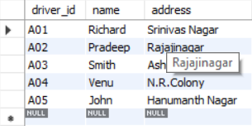

insert into car values('KA052250','Indica', 1990);

insert into car values('KA031181','Lancer', 1957);

insert into car values('KA095477','Toyota', 1998);

insert into car values('KA053408','Honda', 2008);

insert into car values('KA041702','Audi', 2005);

select * from car;

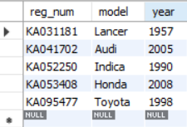

insert into accident values(11,'2001-01-03','Mysore Road');

insert into accident values(12,'2002-01-04','Southend Circle');

insert into accident values(13,'2021-01-03','Bulltemple Road');

insert into accident values(14,'2017-02-08','Mysore Road');

insert into accident values(15,'2008-03-05 ','Kanakpura Road');

select * from accident;

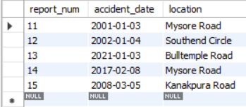

insert into owns values('A01','KA052250');

insert into owns values('A02','KA053408');

insert into owns values('A03','KA031181');

insert into owns values('A04','KA095477');

insert into owns values('A05','KA041702');

select * from owns;

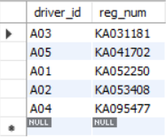

insert into participated values('A01','KA052250',11,10000);

insert into participated values('A02','KA053408',12,50000);

insert into participated values('A03','KA095477',13,25000);

insert into participated values('A04','KA031181',14,3000);

insert into participated values('A05','KA041702',15,5000);

select * from participated;

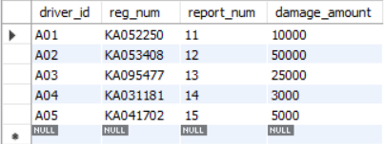

**iii. Demonstrate how you**

**a. Update the damage amount for the car with a specific Regno in the accident with report number 12 to 25000.**

**b. Add a new accident to the database.**

use INSURANCE;

UPDATE participated

SET damage_amount=25000

WHERE report_num=12;

insert into accident values('16','2009-04-05','Mysore Road');

select * from accident;

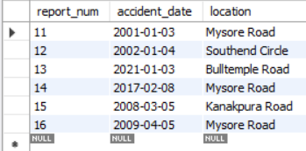

**iv. Find the total number of people who owned cars that involved in accidents in 2008.**

use INSURANCE;

SELECT COUNT(DISTINCT driver_id) FROM accident, participated

WHERE accident.report_num = participated.report_num

AND accident_date LIKE '2008%';

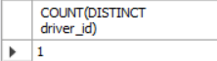

**v. Find the number of accidents in which cars belonging to a specific model were involved**

use INSURANCE;

SELECT COUNT(report_num) FROM car, participated

WHERE car.reg_num = participated.reg_num

AND model='Lancer';

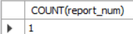

**PROGRAM 2: BANKING ENTERPRISE**

**DATABASE**

Consider the following database for a banking enterprise.

**Branch** (branch-name: String, branch-city: String, assets: real)

**BankAccount**(accno: int, branch-name: String, balance: real)

**BankCustomer** (customer-name: String, customer-street: String, customer-city: String)

**Depositer**(customer-name: String, accno: int)

**Loan** (loan-number: int, branch-name: String, amount: real)

i. Create the above tables by properly specifying the primary keys and the

foreign keys.

ii. Enter at least five tuples for each relation.

iii. Find all the customers who have at least two accounts at the *Main* branch (ex. SBI_ResidencyRoad).

iv. Find all the customers who have an account at *all* the branches located in a

specific city (Ex. Delhi).

v. Demonstrate how you delete all account tuples at every branch located in

a specific city (Ex. Bombay).

**INTRODUCTION:** This database is developed for supporting banking facilities. Details of the branch along with the accounts and loans handled by them are recorded. Also details of the depositors of the corresponding branches are maintained.

**Schema Diagram**

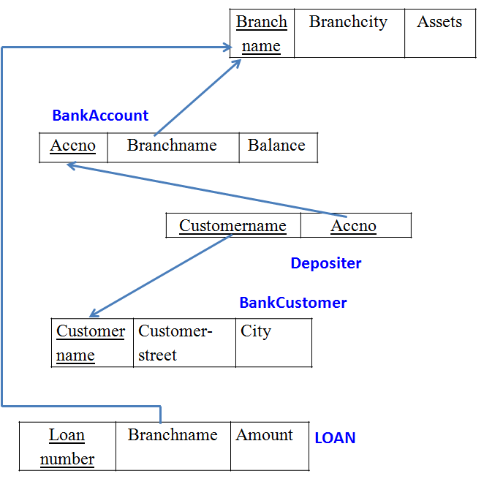

**i. Create the above tables by properly specifying the primary keys and the**

**foreign keys.**

create database Bank;

use Bank;

create table Branch(

branch_name varchar(30),

branch_city varchar(30),

assests real,

primary key(branch_name));

create table BankCustomer(

customer_name varchar(30),

customer_street varchar(30),

customer_city varchar(30),

primary key(customer_name));

create table BankAccount(

accno int,

branch_name varchar(20),

balance real,

primary key(accno),

foreign key(branch_name) references Branch(branch_name));

create table Depositer(

customer_name varchar(20),

accno int,

primary key(customer_name,accno),

foreign key(customer_name) references BankCustomer(customer_name),

foreign key(accno) references BankAccount(accno)

);

create table Loan(

loan_number int,

branch_name varchar(20),

Amount real,

primary key(loan_number),

foreign key(branch_name) references Branch(branch_name)

);

**ii. Enter at least five tuples for each relation.**

use Bank;

insert into Branch values('SBI_Chamrajpet','Bangalore',50000);

insert into Branch values('SBI_ResidencyRoad','Bangalore',10000);

insert into Branch values('SBI_ShivajiRoad','Bangalore',20000);

insert into Branch values('SBI_ParliamentRoad','Delhi',10000);

insert into Branch values('SBI_Jantarmantar','Delhi',20000);

select *from Branch;

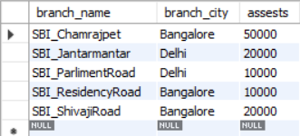

insert into Loan values(2,'SBI_ResidencyRoad',2000);

insert into Loan values(1,'SBI_Chamrajpet',1000);

insert into Loan values(3,'SBI_ShivajiRoad',3000);

insert into Loan values(4,'SBI_ParliamentRoad',4000);

insert into Loan values(5,'SBI_Jantarmantar',3000);

select *from Loan;

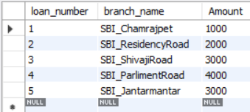

insert into BankAccount values(1,'SBI_Chamrajpet',2000);

insert into BankAccount values(2,'SBI_ResidencyRoad',5000);

insert into BankAccount values(3,'SBI_ShivajiRoad',6000);

insert into BankAccount values(4,'SBI_ParliamentRoad',9000);

insert into BankAccount values(5,'SBI_Jantarmantar',8000);

insert into BankAccount values(6, 'SBI_ShivajiRoad', 4000);

insert into BankAccount values(8, 'SBI_ResidencyRoad', 4000);

insert into BankAccount values(9, 'SBI_ParliamentRoad', 3000);

insert into BankAccount values(10, 'SBI_ResidencyRoad', 5000);

insert into BankAccount values(11, 'SBI_Jantarmantar', 2000);

select *from BankAccount;

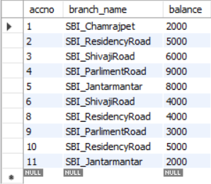

insert into BankCustomer values ('Avinash', 'Bull_Temple_Road', 'Bangalore');

insert into BankCustomer values ('Dinesh', 'Bannergatta_Road', 'Bangalore');

insert into BankCustomer values ('Mohan', 'National_College_Road', 'Bangalore');

insert into BankCustomer values ('Nikhil', 'Akbar_Road', 'Delhi');

insert into BankCustomer values ('Ravi', 'Prithviraj_Road', 'Delhi');

select *from BankCustomer;

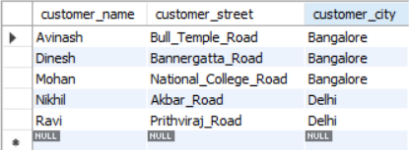

insert into Depositer values('Avinash', 1);

insert into Depositer values('Dinesh', 2);

insert into Depositer values('Nikhil', 4);

insert into Depositer values('Ravi', 5);

insert into Depositer values('Avinash', 8);

insert into Depositer values('Nikhil', 9);

insert into Depositer values('Dinesh', 10);

insert into Depositer values('Nikhil', 11);

select *from Depositer;

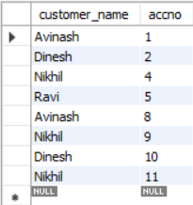

**iii. Find all the customers who have at least two accounts at the *Main* branch (ex. SBI_ResidencyRoad).**

use Bank;

select c.customer_name

from BankCustomer c

where exists(

select d.customer_name

from Depositer d, BankAccount ba

where d.accno=ba.accno

and c.customer_name=d.customer_name

and ba.branch_name='SBI_ResidencyRoad'

group by d.customer_name

having count(d.customer_name)>=2);

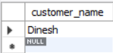

**iv. Find all the customers who have an account at *all* the branches located in a**

**specific city (Ex. Delhi).**

use Bank;

select distinct d.customer_name

from Depositer d

where exists(

select * from BankAccount ba

where ba.accno=d.accno

and exists(

select * from Branch b

where b.branch_name = ba.branch_name

and b.branch_city='Delhi'));

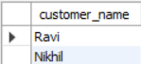

**v. Demonstrate how you delete all account tuples at every branch located in**

**a specific city (Ex. Bombay).**

use Bank;

delete from BankAccount

where branch_name in(

select branch_name

from branch

where branch_city = 'Bombay');

select *from BankAccount;

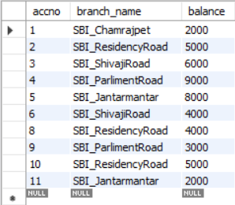

**PROGRAM 3: SUPPLIER DATABASE**

Consider the following schema:

SUPPLIERS(sid: integer, sname: string, address: string)

PARTS(pid: integer, pname: string, color: string)

CATALOG(sid: integer, pid: integer, cost: real)

The Catalog relation lists the prices charged for parts by Suppliers.

**Schema Diagram**

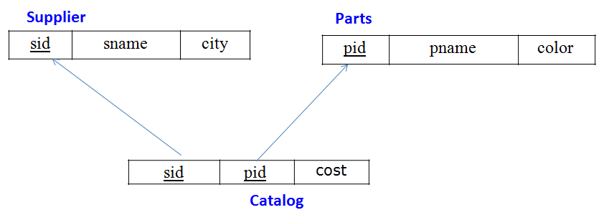

**Table Data**

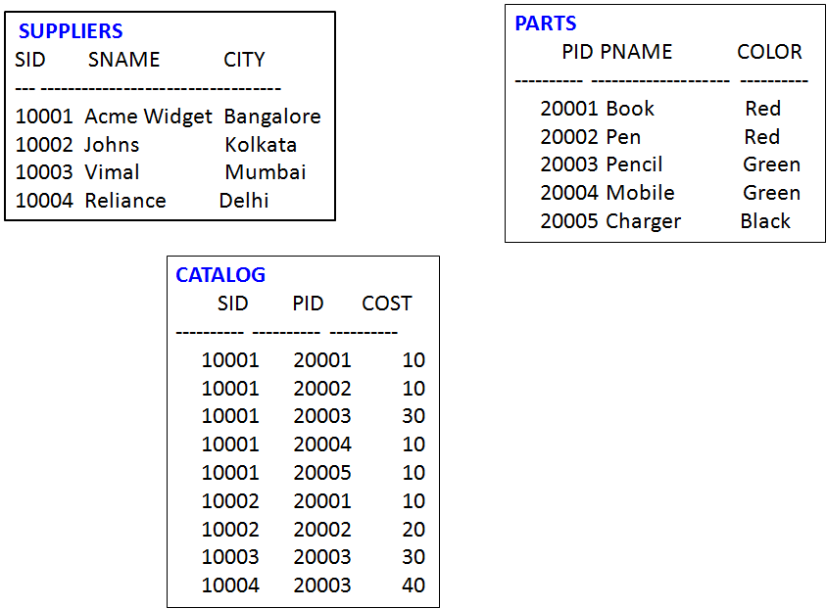

**QUERY 1**

create database Suppliers;

use Suppliers;

create table supplier(

sid int,

sname char(30),

city char(30));

create table catalog(

sid int,

pid int,

cost int);

create table parts(

pid int,

pname varchar(15),

color varchar(10),

primary key (pid));

**QUERY 2**

use Suppliers;

insert into supplier values(10001, 'Acme Widget','Bengaluru');

insert into supplier values(10002,'Johns','Kolkata');

insert into supplier values(10003, 'Vimal','Mumbai');

insert into supplier values(10004, 'Reliance','Delhi');

insert into supplier values(10005, 'Mahindra','Mumbai');

select * from supplier;

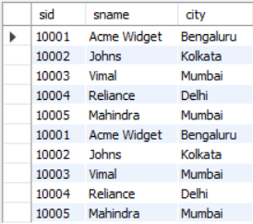

insert into parts values(20001, 'Book','Red');

insert into parts values(20002, 'Pen','Red');

insert into parts values(20003, 'Pencil','Green');

insert into parts values(20004, 'Mobile','Green');

insert into parts values(20005, 'Charger','Black');

select * from parts;

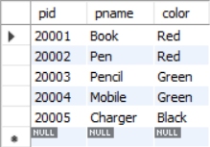

insert into catalog values(10001, '20001','10');

insert into catalog values(10001, '20002','10');

insert into catalog values(10001, '20003','30');

insert into catalog values(10001, '20004','10');

insert into catalog values(10001, '20005','10');

insert into catalog values(10002, '20001','10');

insert into catalog values(10002, '20002','20');

insert into catalog values(10003, '20003','30');

insert into catalog values(10004, '20003','40');

select * from catalog;

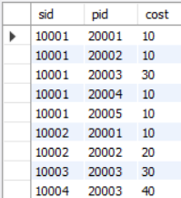

**1.Find the pnames of parts for which there is some supplier.**

use Suppliers;

select distinct p.pname

from parts p,catalog c

where p.pid = c.pid;

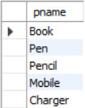

**2.Find the snames of suppliers who supply every part.**

use Suppliers;

select s.sname from supplier s

where not exists(

select p.pid from parts p

where not exists(

select c.sid from catalog c

where c.sid = s.sid

and c.pid = p.pid));

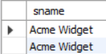

**3.Find the snames of suppliers who supply every red part.**

use Suppliers;

select s.sname from supplier s

where not exists(

select p.pid from parts p

where p.color = 'Red'

and not exists (

select c.sid from catalog c

where c.sid = s.sid

and c.pid = p.pid));

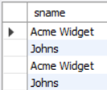

**4.Find the pnames of parts supplied by Acme Widget Suppliers and by no one else.**

use Suppliers;

select p.pname from parts p,catalog c,supplier s

where p.pid = c.pid and c.sid = s.sid and s.sname = 'Acme Widget'

and not exists(

select * from catalog c1, supplier s1

where p.pid = c1.pid

and c1.sid = s1.sid

and s1.sname <> 'Acme Widget');

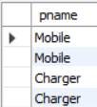

**5.Find the sids of suppliers who charge more for some part than the average cost of that part (averaged over all the suppliers who supply that part).**

use Suppliers;

select distinct c.sid from catalog c

where c.cost > (select avg (c1.cost)

from catalog c1

where c1.pid = c.pid );

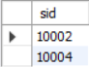

**6.For each part, find the sname of the supplier who charges the most for that part.**

use Suppliers;

select p.pid, s.sname

from parts p, supplier s, catalog c

where c.pid = p.pid

and c.sid = s.sid

and c.cost = (select MAX(c1.cost)

from catalog c1

where c1.pid = p.pid);

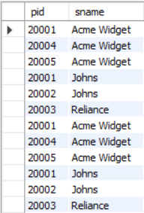

**PROGRAM 4: STUDENT FACULTY DATABASE**

Consider the following database for student enrollment for course :

STUDENT(snum: integer, sname:string, major: string, lvl: string, age: integer)

CLASS(cname: string, meetsat: time, room: string, fid: integer)

ENROLLED(snum: integer, cname:string)

FACULTY(fid: integer, fname:string, deptid: integer)

create database StudentFaculty;

use StudentFaculty;

create table student(

snum int,

sname varchar(10),

major varchar(2),

lvl varchar(2),

age int,

primary key (snum));

create table faculty(

fid int,

fname varchar(20),

deptid int,

primary key(fid));

create table class(

cname varchar(20),

meetsat timestamp,

room varchar(10),

fid int,

primary key (cname),

foreign key(fid) references faculty(fid));

create table enrolled(

snum int,

cname varchar(20),

primary key(snum,cname),

foreign key(snum) references student(snum),

foreign key(cname) references class(cname));

use StudentFaculty;

insert into student values(1, 'jhon', 'CS', 'Sr', 19);

insert into student values(2, 'Smith', 'CS', 'Jr', 20);

insert into student values(3 , 'Jacob', 'CV', 'Sr', 20);

insert into student values(4, 'Tom ', 'CS', 'Jr', 20);

insert into student values(5, 'Rahul', 'CS', 'Jr', 20);

insert into student values(6, 'Rita', 'CS', 'Sr', 21);

select * from student;

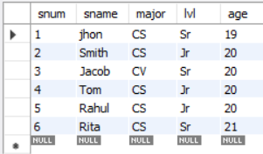

insert into faculty values(11, 'Harish', 1000);

insert into faculty values(12, 'MV', 1000);

insert into faculty values(13 , 'Mira', 1001);

insert into faculty values(14, 'Shiva', 1002);

insert into faculty values(15, 'Nupur', 1000);

select * from faculty;

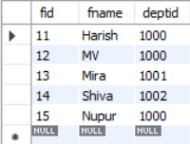

insert into class values('class1', '12/11/15 10:15:16', 'R1', 14);

insert into class values('class10', '12/11/15 10:15:16', 'R128', 14);

insert into class values('class2', '12/11/15 10:15:20', 'R2', 12);

insert into class values('class3', '12/11/15 10:15:25', 'R3', 12);

insert into class values('class4', '12/11/15 20:15:20', 'R4', 14);

insert into class values('class5', '12/11/15 20:15:20', 'R3', 15);

insert into class values('class6', '12/11/15 13:20:20', 'R2', 14);

insert into class values('class7', '12/11/15 10:10:10', 'R3', 14);

select * from class;

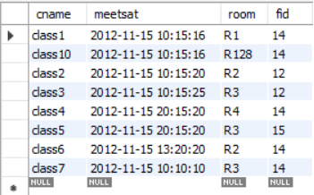

insert into enrolled values(1, 'class1');

insert into enrolled values(2, 'class1');

insert into enrolled values(3, 'class3');

insert into enrolled values(4, 'class3');

insert into enrolled values(5, 'class4');

insert into enrolled values(1, 'class5');

insert into enrolled values(2, 'class5');

insert into enrolled values(3, 'class5');

insert into enrolled values(4, 'class5');

insert into enrolled values(5, 'class5');

select * from enrolled;

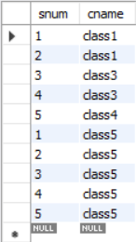

**i. Find the names of all Juniors (level = JR) who are enrolled in a class taught by Harish**

use StudentFaculty;

select distinct S.sname from student S, class C, enrolled E, faculty F

where S.snum = E.snum

and E.cname = C.cname

and C.fid = F.fid

and F.fname = 'Harish' and S.lvl = 'Jr';

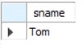

**ii.Find the names of all classes that either meet in room R128 or have five or more Students enrolled.**

select C.cname from class C

where C.room = 'R128'

or C.cname in (

select E.cname from enrolled E

group by E.cname

having COUNT(*) >= 5);

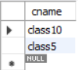

**iii. Find the names of all students who are enrolled in two classes that meet at the same time.**

select distinct S.sname from student S

where S.snum in (

select E1.snum from enrolled E1, enrolled E2, class C1, class C2

where E1.snum = E2.snum

and E1.cname <> E2.cname

and E1.cname = C1.cname

and E2.cname = C2.cname

and C1.meetsat = C2.meetsat);

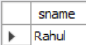

**iv.Find the names of faculty members who teach in every room in which some class is taught.**

select f.fname,f.fid from faculty f

where f.fid in (

select fid from class

group by fid having COUNT(*)=(

select COUNT(distinct room) from class) );

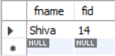

**v.Find the names of faculty members for whom the combined enrollment of the courses that they teach is less than five.**

select distinct F.fname from faculty F

where 5 > (

select COUNT(E.snum) from class C, enrolled E

where C.cname = E.cname

and C.fid = F.fid);

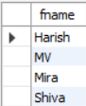

**vi. Find the names of students who are not enrolled in any class.**

select distinct S.sname from student S

where S.snum not in (

select E.snum from enrolled E );

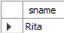

**vii.For each age value that appears in Students, find the level value that appears most** **often.**

select S.age, S.lvl from Student S

group by S.age, S.lvl

having S.lvl in (

select S1.lvl from Student S1

where S1.age = S.age

group by S1.lvl, S1.age

having COUNT(*) >= all (select COUNT(*)

from Student S2

where s1.age = S2.age

group by S2.lvl, S2.age));

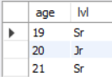

**PROGRAM 5: AIRLNE FLIGHT DATABASE**

Consider the following database that keeps track of airline flight information:

FLIGHTS(flno: integer, from: string, to: string, distance: integer, departs: time, arrives: time, price: integer)

AIRCRAFT(aid: integer, aname: string, cruisingrange: integer)

CERTIFIED(eid: integer, aid: integer)

EMPLOYEES(eid: integer, ename: string, salary: integer)

Note that the Employees relation describes pilots and other kinds of employees as well; Every pilot is certified for some aircraft, and only pilots are certified to fly.

create database flightdb;

use flightdb;

create table flights(

flno int,

fromplace varchar(15),

toplace varchar(15),

distance int,

departs datetime,

arrives datetime,

price int,

primary key (flno));

create table aircraft(

aid int,

aname varchar(15),

cruisingrange int,

primary key (aid));

create table employees (

eid int,

ename varchar(15),

salary int,

primary key (eid));

create table certified (

eid int,

aid int,

foreign key (eid) references employees(eid),

foreign key (aid) references aircraft(aid));

use flightdb;

insert into flights values(101, 'Bangalore', 'Delhi', 2500, '2005-05-13 07:15:31', '2005-05-13 18:15:31', 5000);

insert into flights values(102, 'Bangalore', 'Lucknow', 3000, '2013-05-05 07:15:31', '2013-05-05 11:15:31', 6000);

insert into flights values(103, 'Lucknow', 'Delhi', 500, '2013-05-05 12:15:31', '2013-05-05 17:15:31',

3000);

insert into flights values(107, 'Bangalore', 'Frankfurt', 8000, '2013-05-05 07:15:31', '2013-05-05 22:15:31', 60000);

insert into flights values(104, 'Bangalore', 'Frankfurt', 8500, '2013-05-05 07:15:31', '2013-05-05 23:15:31', 75000);

insert into flights values(105, 'Kolkata', 'Delhi', 3400, '2013-05-05 07:15:31', '2013-05-05 09:15:31',

7000);

insert into flights values(106, 'Bangalore', 'Kolkata', 1000, '2013-05-05 01:15:30', '2013-05-05 09:20:30', 10000);

insert into flights values(108, 'Lucknow', 'Kolkata', 1000, '2013-05-05 11:30:30', '2013-05-05 15:20:30', 10000);

select * from flights;

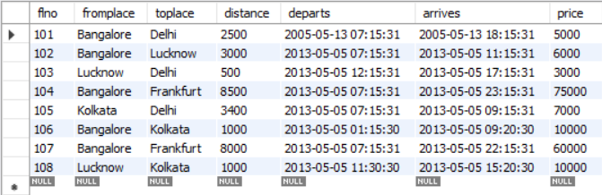

insert into aircraft values(101, '747', 3000);

insert into aircraft values(102, 'Boeing', 900);

insert into aircraft values(103, '647', 800);

insert into aircraft values(104, 'Dreamliner', 10000);

insert into aircraft values(105, 'Boeing', 3500);

insert into aircraft values(106, '707', 1500);

insert into aircraft values(107, 'Dream', 120000);

insert into aircraft values(108, '707', 760);

insert into aircraft values(109, '747', 1000);

select * from aircraft;

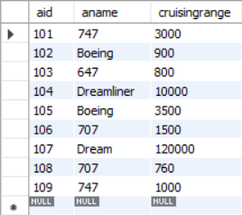

insert into employees values(701, 'A', 50000);

insert into employees values(702, 'B', 100000);

insert into employees values(703, 'C', 150000);

insert into employees values(704, 'D', 90000);

insert into employees values(705, 'E', 40000);

insert into employees values(706, 'F', 60000);

insert into employees values(707, 'G', 90000);

select * from employees;

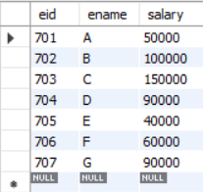

insert into certified values(701, 101);

insert into certified values(701, 102);

insert into certified values(701, 106);

insert into certified values(701, 105);

insert into certified values(702, 104);

insert into certified values(703, 104);

insert into certified values(704, 104);

insert into certified values(702, 107);

insert into certified values(703, 107);

insert into certified values(704, 107);

insert into certified values(702, 101);

insert into certified values(702, 108);

insert into certified values(701, 109);

select * from certified;

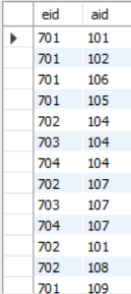

**i.Find the names of aircraft such that all pilots certified to operate them have salaries more than Rs.80,000.**

use flightdb;

select distinct a.aname from aircraft a where a.aid in (

select c.aid from certified c, employees e

where c.eid = e.eid and not exists(

select * from employees e1 where e1.eid=e.eid and e1.salary<80000));

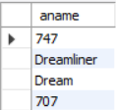

**ii.For each pilot who is certified for more than three aircrafts, find the eid and the maximum cruisingrange of the aircraft for which she or he is certified.**

use flightdb;

select max(a.cruisingrange), c.eid from certified c, aircraft a

where c.aid = a.aid group by c.eid having count(c.eid)>3;

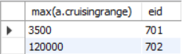

**iii.Find the names of pilots whose salary is less than the price of the cheapest route from Bengaluru to Frankfurt.**

use flightdb;

select ename from employees

where salary <(select min(price)

from flights

where fromplace='Bangalore' and toplace='Frankfurt');

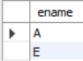

**iv.For all aircraft with cruisingrange over 1000 Kms, find the name of the aircraft and the average salary of all pilots certified for this aircraft.**

use flightdb;

select avg(e.salary), c.aid from certified c, employees e

where c.aid in(select aid

from aircraft where cruisingrange>1000)

and e.eid = c.eid group by c.aid;

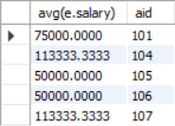

**v.Find the names of pilots certified for some Boeing aircraft.**

use flightdb;

select ename from employees where eid in(

select eid from certified where aid in(

select aid from aircraft where aname = 'Boeing'));

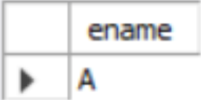

**vi.Find the aids of all aircraft that can be used on routes from Bengaluru to New Delhi.**

use flightdb;

select aname from aircraft

where cruisingrange > any(select distance

from flights where fromplace='Bangalore' and toplace='Delhi');

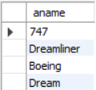

**vii.A customer wants to travel from Bangalore to Kolkata New with no more than two changes of flight. List the choice of departure times from Madison if the customer wants to arrive in Kolkata by 6 p.m.**

use flightdb;

select F.flno, F.departs from flights F

where F.flno in ((select F0.flno

from flights F0

where F0.fromplace = 'Bangalore' and F0.toplace = 'Kolkata'

and EXTRACT(hour from F0.arrives) < 18 )

UNION(select F0.flno

from flights F0, flights F1

where F0.fromplace = 'Bangalore' and F0.toplace <> 'Kolkata'

and F0.toplace = F1.fromplace and F1.toplace = 'Kolkata'

and F1.departs > F0.arrives

and EXTRACT(hour from F1.arrives) < 18)

UNION(select F0.flno

from flights F0, flights F1, flights F2

where F0.fromplace = 'Bangalore'

and F0.toplace = F1.fromplace

and F1.toplace = F2.fromplace

and F2.toplace = 'Kolkata'

and F0.toplace <> 'Kolkata'

and F1.toplace <> 'Kolkata'

and F1.departs > F0.arrives

and F2.departs > F1.arrives

and EXTRACT(hour from F2.arrives) < 18))

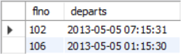

**PROGRAM 6: ORDER DATABASE**

**Q.Consider the following schema for Order Database:**

**SALESMAN (*Salesman_id, Name, City, Commission*)**

**CUSTOMER (*Customer_id, Cust_Name, City, Grade, Salesman_id*)**

**ORDERS (*Ord_No, Purchase_Amt, Ord_Date, Customer_id, Salesman_id*)**

**Write SQL queries to**

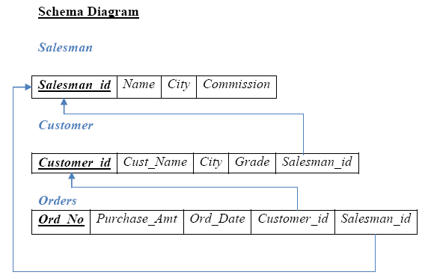

**1. Count the customers with grades above Bangalore’s average.**

**2. Find the name and numbers of all salesmen who had more than one customer.**

**3. List all salesmen and indicate those who have and don’t have customers in their cities (Use UNION operation.)**

**4. Create a view that finds the salesman who has the customer with the highest order of a day.**

**5. Demonstrate the DELETE operation by removing salesman with id 1000. All his orders must also be deleted.**

**QUERY 1**

create database order_database;

use order_database;

create table salesman(

Salesman_id int,

Name char(30),

City varchar(30),

Commission varchar(5),

primary key(Salesman_id));

create table customer(

Customer_id int,

Cust_Name char(30),

City varchar(30),

Grade int,

Salesman_id int,

primary key(Customer_id,Salesman_id),

foreign key(Salesman_id) references salesman(Salesman_id) on delete cascade);

create table orders(

Ord_No int,

Purchase_Amt int,

Ord_Date varchar(20),

Customer_id int,

Salesman_id int,

primary key(Customer_id,Salesman_id),

foreign key(Customer_id) references customer(Customer_id) on delete cascade,

foreign key(Salesman_id) references salesman(Salesman_id) on delete cascade);

**QUERY 2**

use order_database;

insert into salesman values('1000','John','Bangalore','25%');

insert into salesman values('2000','Ravi','Bangalore','20%');

insert into salesman values('3000','Kumar','Mysore','15%');

insert into salesman values('4000','Smith','Delhi','30%');

insert into salesman values('5000','Harsha','Hyderaba','15%');

select * from salesman;

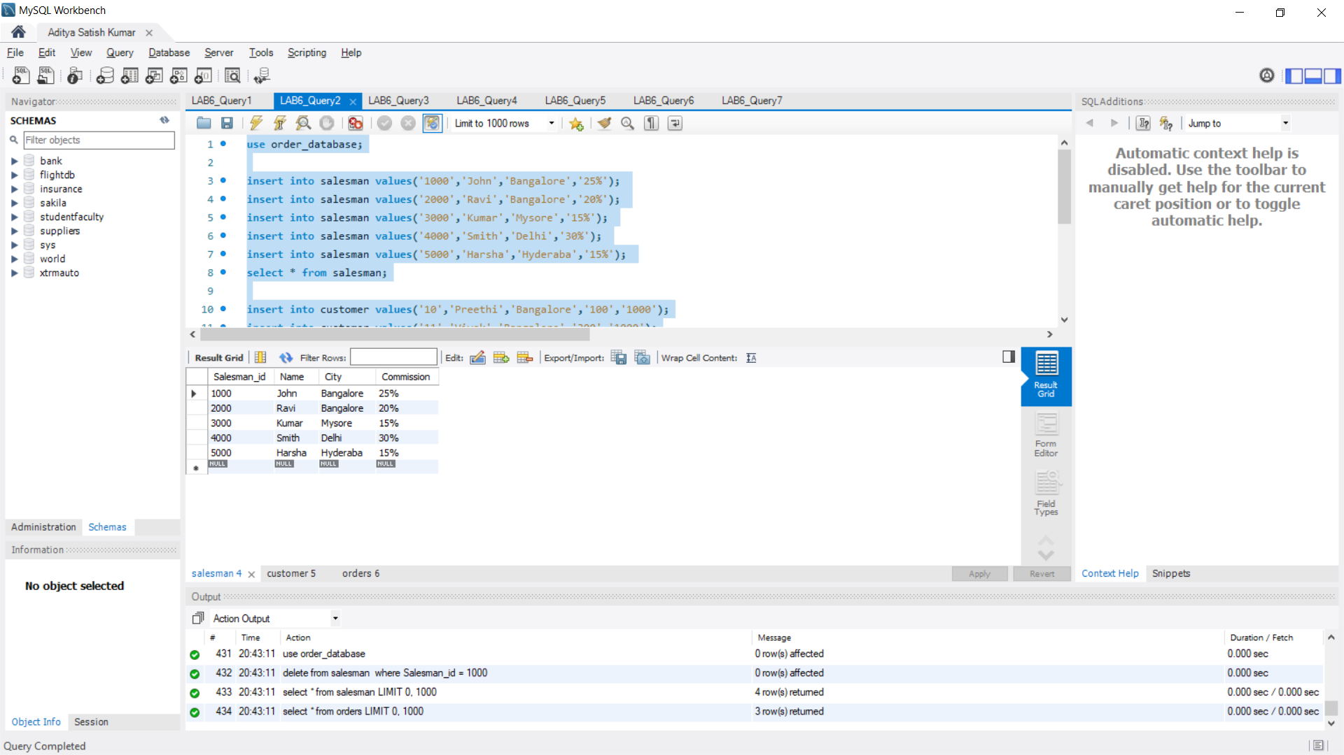

insert into customer values('10','Preethi','Bangalore','100','1000');

insert into customer values('11','Vivek','Bangalore','300','1000');

insert into customer values('12','Bhaskar','Chennai','400','2000');

insert into customer values('13','Chethan','Bangalore','200','2000');

insert into customer values('14','Mamatha','Bangalore','400','3000');

select * from customer;

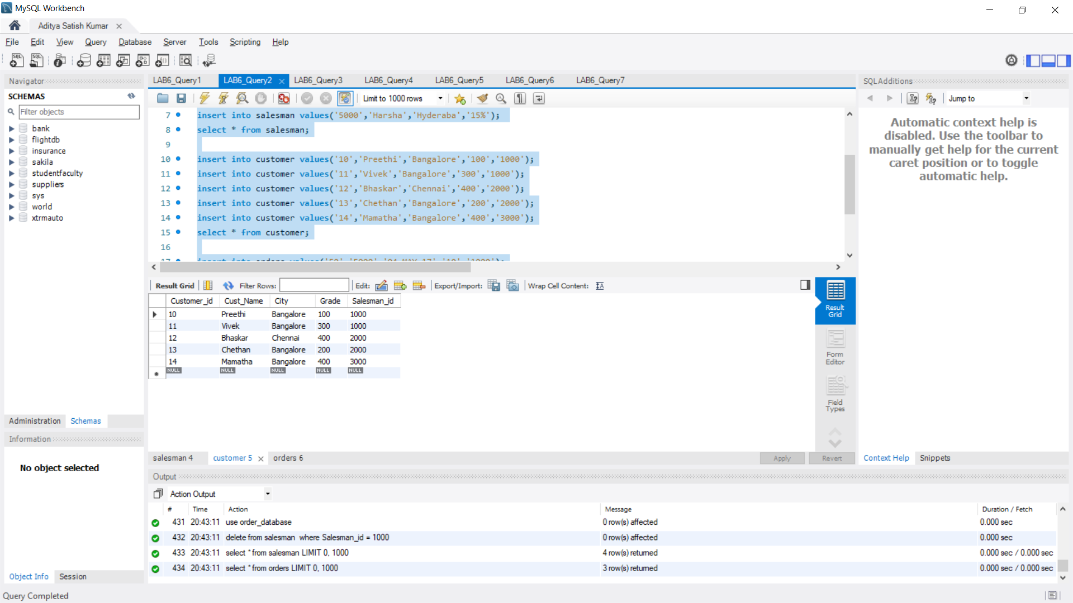

insert into orders values('50','5000','04-MAY-17','10','1000');

insert into orders values('51','450','20-JAN-17','10','2000');

insert into orders values('52','1000','24-FEB-17','13','2000');

insert into orders values('53','3500','13-APR-17','14','3000');

insert into orders values('54','550','09-MAR-17','12','2000');

select * from orders;

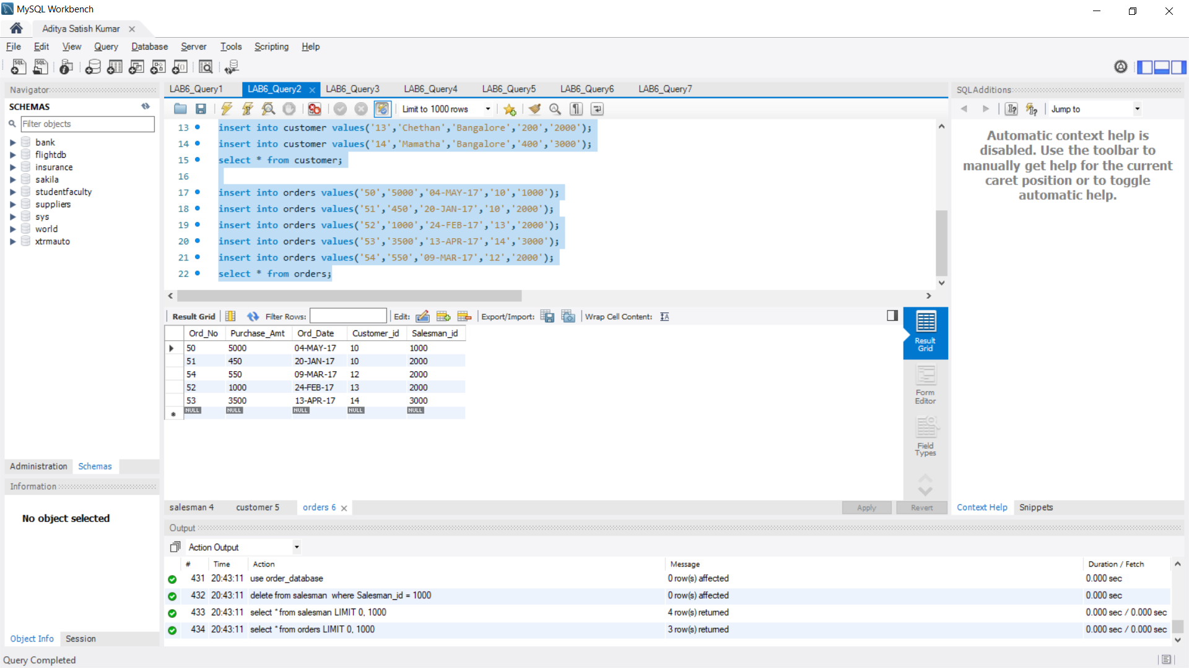

**QUERY 3**

use order_database;

select grade,COUNT(*)

from customer

group by grade

having grade > (select avg(grade)

from customer

where city = 'Bangalore');

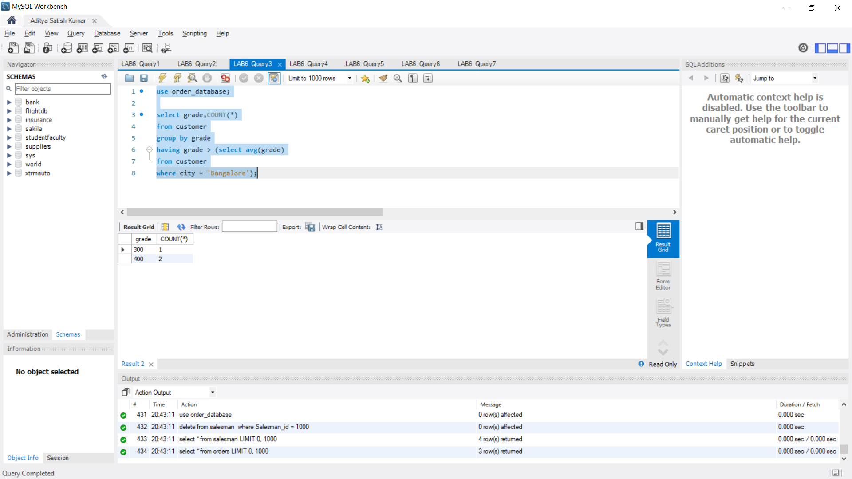

**QUERY 4**

use order_database;

select Name,Salesman_id from salesman s

where 1<(select count(*)

from customer

where Salesman_id=s.Salesman_id);

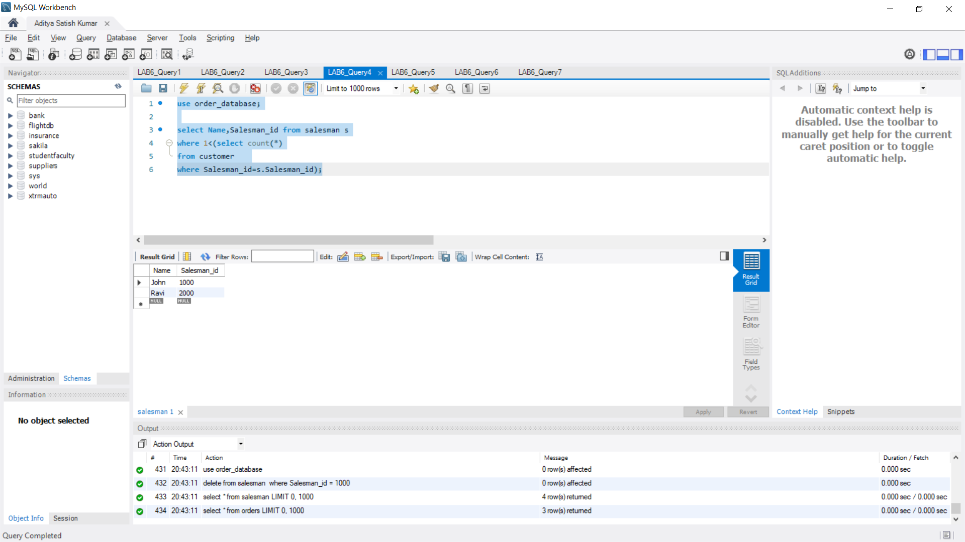

**QUERY 5**

use order_database;

select salesman.salesman_id, name, cust_name, commission

from salesman, customer

where salesman.city = customer.city

union

select salesman_id, name, 'no customer', commission

from salesman

where not city = any(select city

from customer);

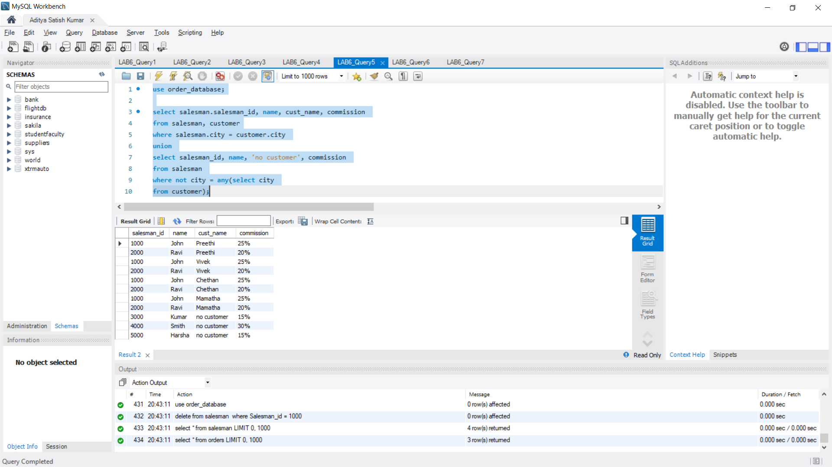

**QUERY 6**

use order_database;

create view highsalesman as

select b.ord_date, a.salesman_id, a.name

from salesman a, orders b

where a.salesman_id = b.salesman_id

and b.purchase_amt=(select max(purchase_amt)

from orders c

where c.ord_date = b.ord_date);

select * from highsalesman;

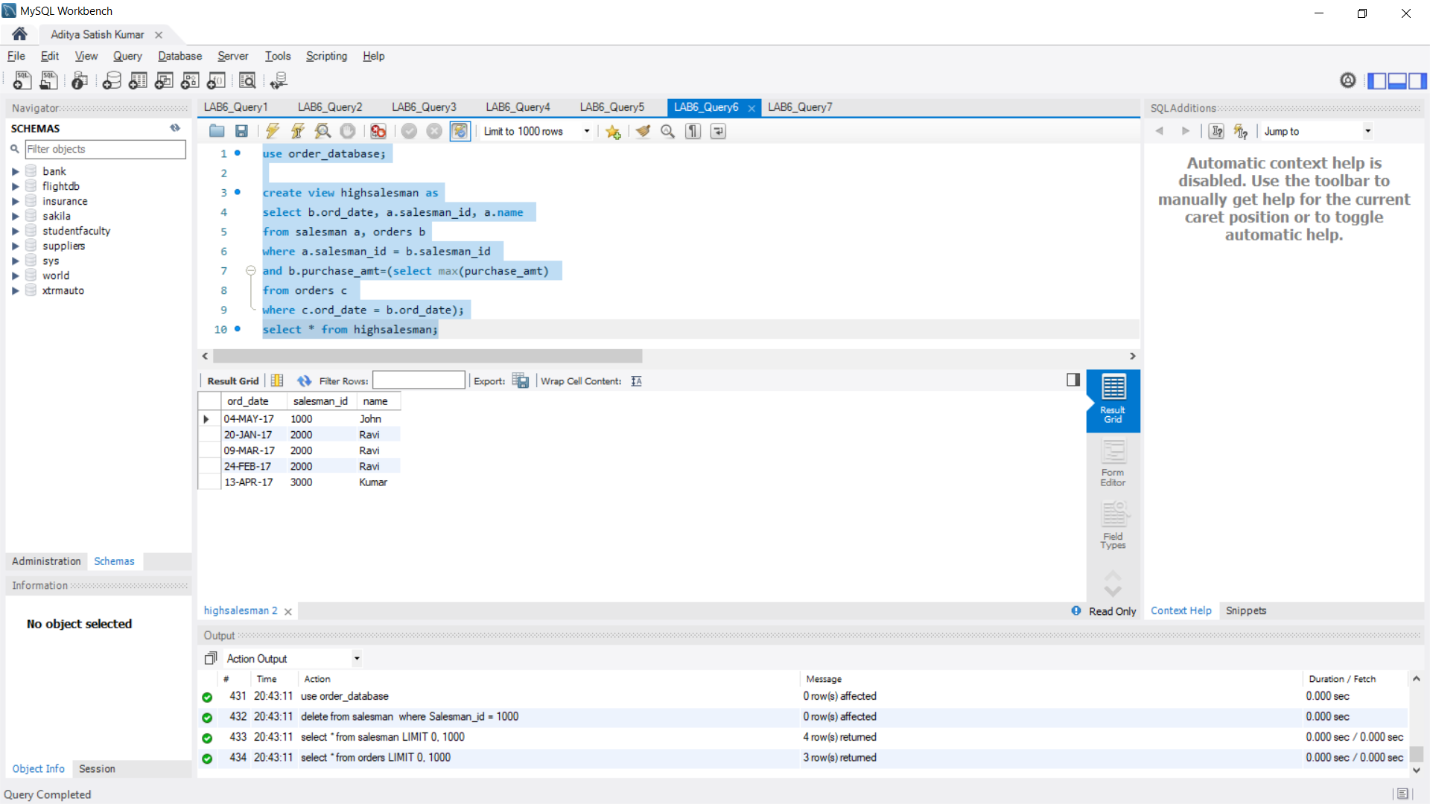

**QUERY 7**

use order_database;

delete from salesman

where Salesman_id = 1000;

select * from salesman;

select * from orders;

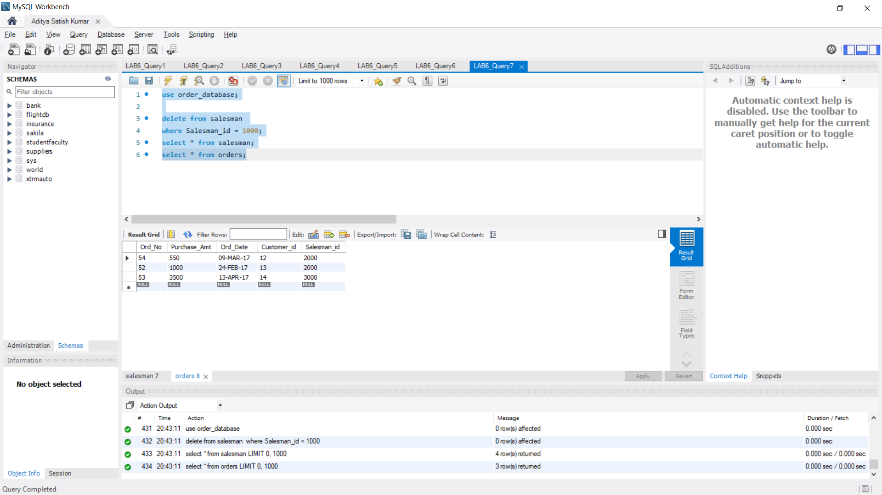

**PROGRAM 7: BOOK DATABASE**

BOOK (Book_id, Title, Publisher_Name, Pub_Year)

BOOK_AUTHORS (Book_id, Author_Name)

PUBLISHER (Name, Address, Phone)

BOOK_COPIES (Book_id, Branch_id, No-of_Copies)

BOOK_LENDING (Book_id, Branch_id, Card_No, Date_Out, Due_Date)

LIBRARY_BRANCH (Branch_id, Branch_Name, Address)

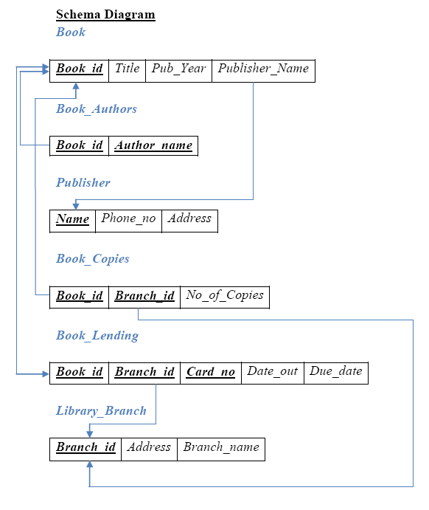

1. Retrieve details of all books in the library – id, title, name of publisher, authors, number of copies in each branch, etc.
2. Get the particulars of borrowers who have borrowed more than 3 books, but from Jan 2017 to Jun 2017
3. Delete a book in BOOK table. Update the contents of other tables to reflect this data manipulation operation.
4. Partition the BOOK table based on year of publication. Demonstrate its working with a simple query.
5. Create a view of all books and its number of copies that are currently available in the Library.

**QUERY 1**

create database book_database;

use book_database;

create table publisher (

name varchar(30),

phone int,

address varchar(50),

primary key(name));

create table book (

book_id int,

title varchar(50),

pub_year varchar(10),

publisher_name varchar(30),

primary key(book_id),

foreign key (publisher_name) references publisher (name) on delete cascade

);

create table book_authors (

author_name varchar(30),

book_id int,

foreign key (book_id) references book (book_id) on delete cascade,

primary key (book_id, author_name));

create table library_branch (

branch_id int,

branch_name varchar(50),

address varchar(50),

primary key(branch_id));

create table book_copies (

no_of_copies int,

book_id int,

branch_id int,

foreign key (book_id) references book (book_id) on delete cascade,

foreign key (branch_id) references library_branch (branch_id) on delete cascade,

primary key (book_id, branch_id));

create table card (

card_no int,

primary key(card_no));

create table book_lending (

date_out date,

due_date date,

book_id int,

branch_id int,

card_no int,

foreign key (book_id) references book (book_id) on delete cascade,

foreign key (branch_id) references library_branch (branch_id) on delete cascade,

foreign key (card_no) references card (card_no) on delete cascade,

primary key (book_id, branch_id, card_no));

**QUERY 2**

use book_database;

insert into publisher values ('mcgraw-hill', 99890, 'bangalore');

insert into publisher values ('pearson', 98890, 'newdelhi');

insert into publisher values ('random house', 74556, 'hyderabad');

insert into publisher values ('hachette livre', 897086, 'chenai');

insert into publisher values ('grupo planeta', 77561, 'bangalore');

select * from publisher;

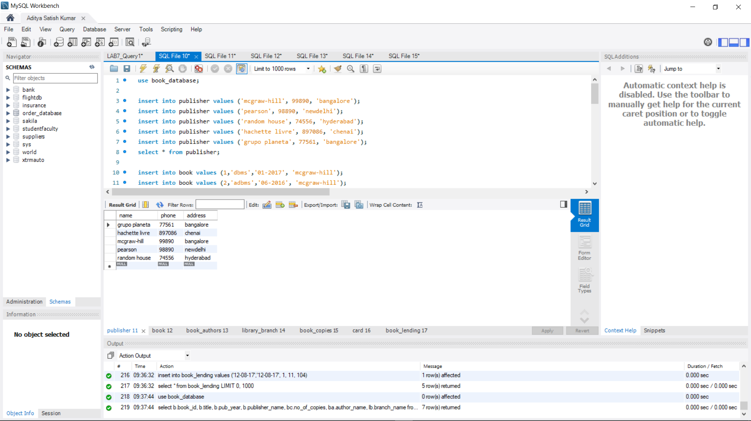

insert into book values (1,'dbms','01-2017', 'mcgraw-hill');

insert into book values (2,'adbms','06-2016', 'mcgraw-hill');

insert into book values (3,'cn','09-2016', 'pearson');

insert into book values (4,'cg','09-2015', 'grupo planeta');

insert into book values (5,'os','05-2016', 'pearson');

select * from book;

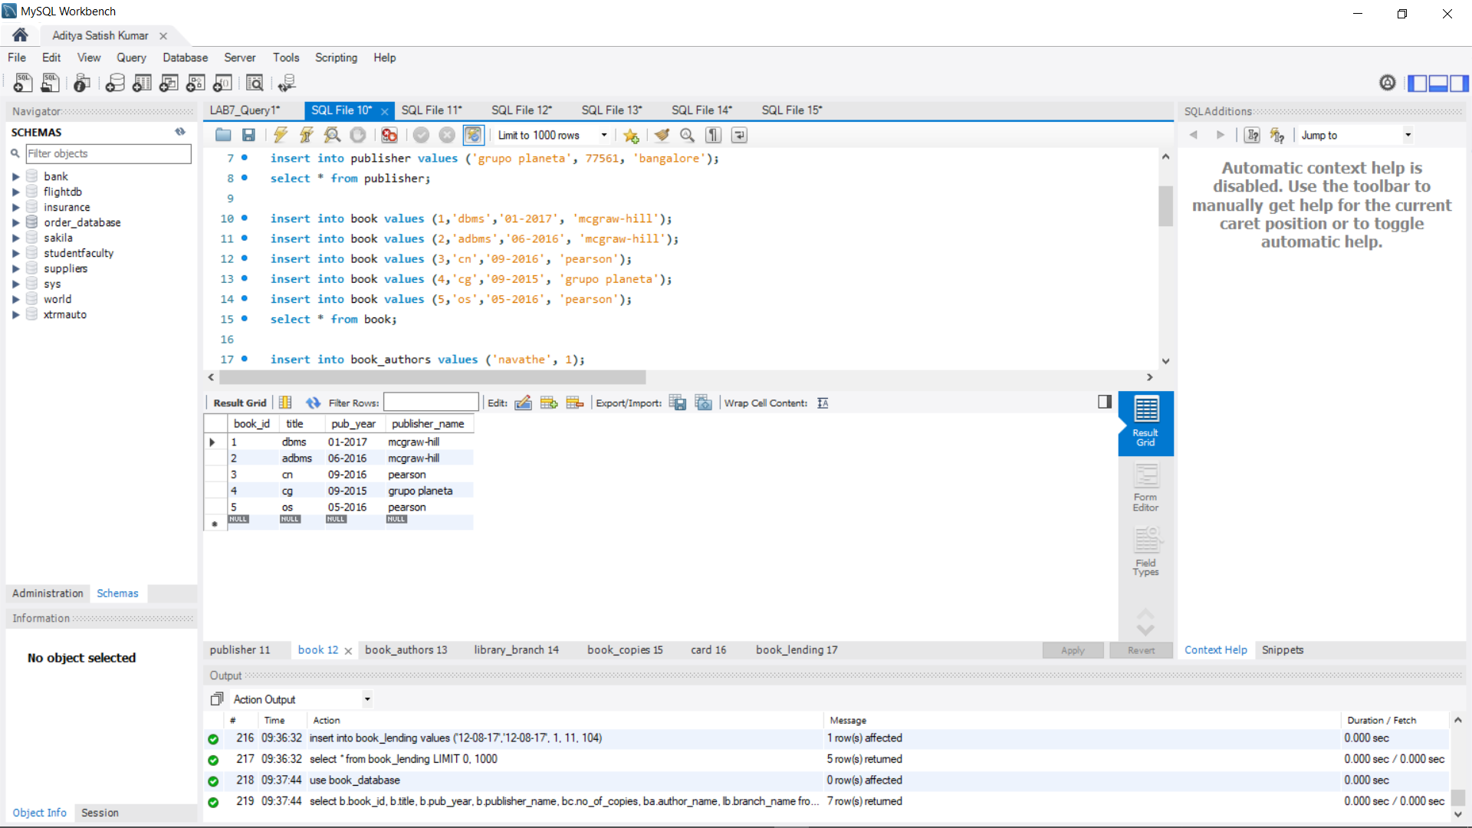

insert into book_authors values ('navathe', 1);

insert into book_authors values ('navathe', 2);

insert into book_authors values ('tanenbaum', 3);

insert into book_authors values ('edward angel', 4);

insert into book_authors values ('galvin', 5);

select * from book_authors;

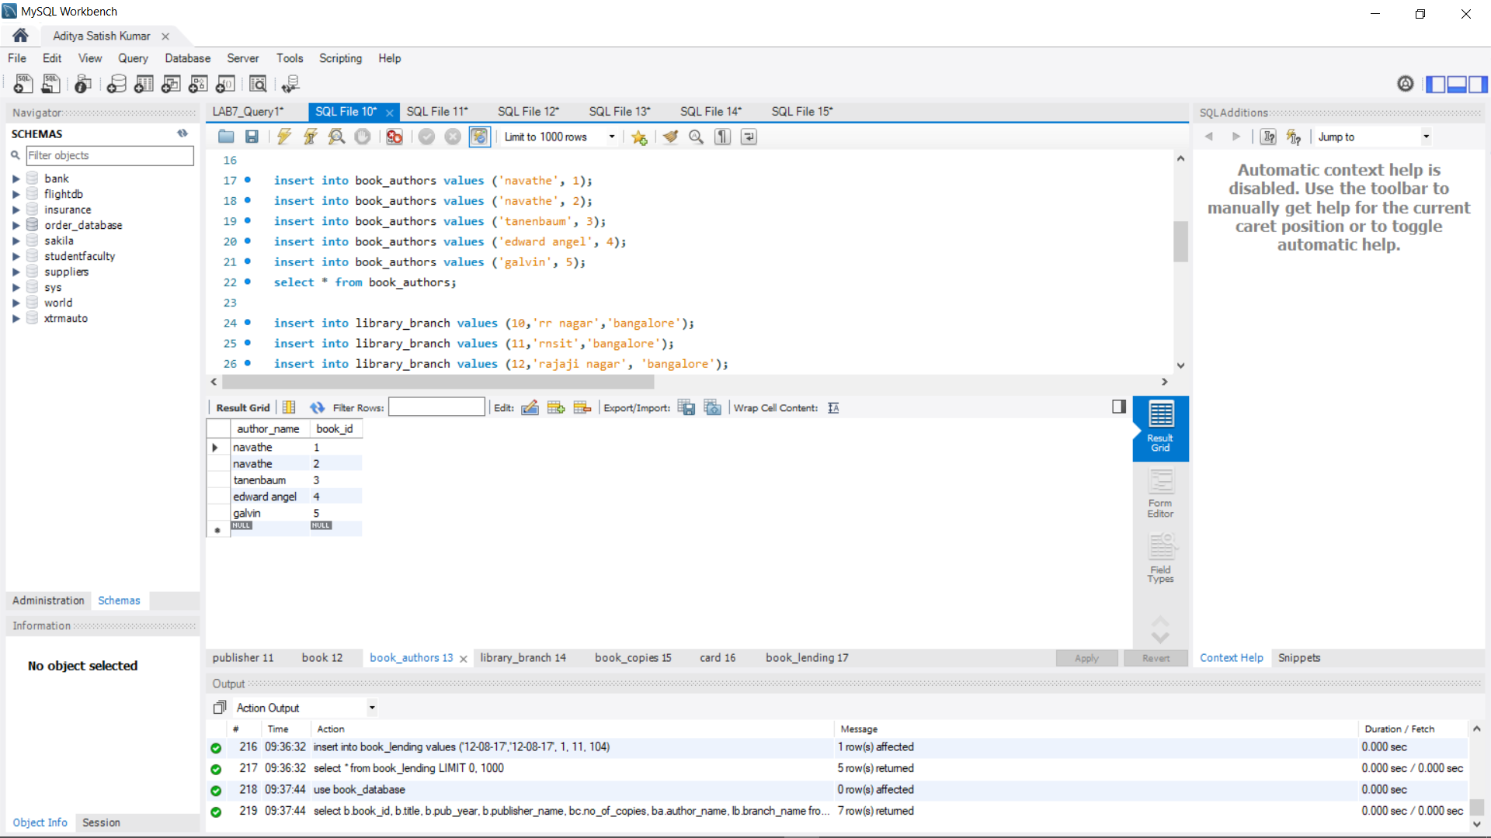

insert into library_branch values (10,'rr nagar','bangalore');

insert into library_branch values (11,'rnsit','bangalore');

insert into library_branch values (12,'rajaji nagar', 'bangalore');

insert into library_branch values (13,'nitte','mangalore');

insert into library_branch values (14,'manipal','udupi');

select * from library_branch;

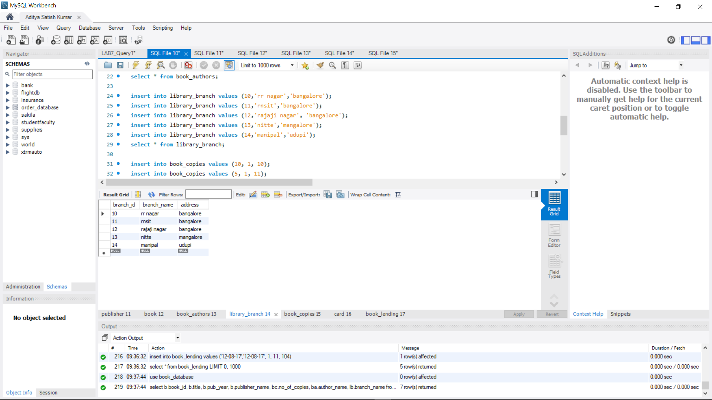

insert into book_copies values (10, 1, 10);

insert into book_copies values (5, 1, 11);

insert into book_copies values (2, 2, 12);

insert into book_copies values (5, 2, 13);

insert into book_copies values (7, 3, 14);

insert into book_copies values (1, 5, 10);

insert into book_copies values (3, 4, 11);

select * from book_copies;

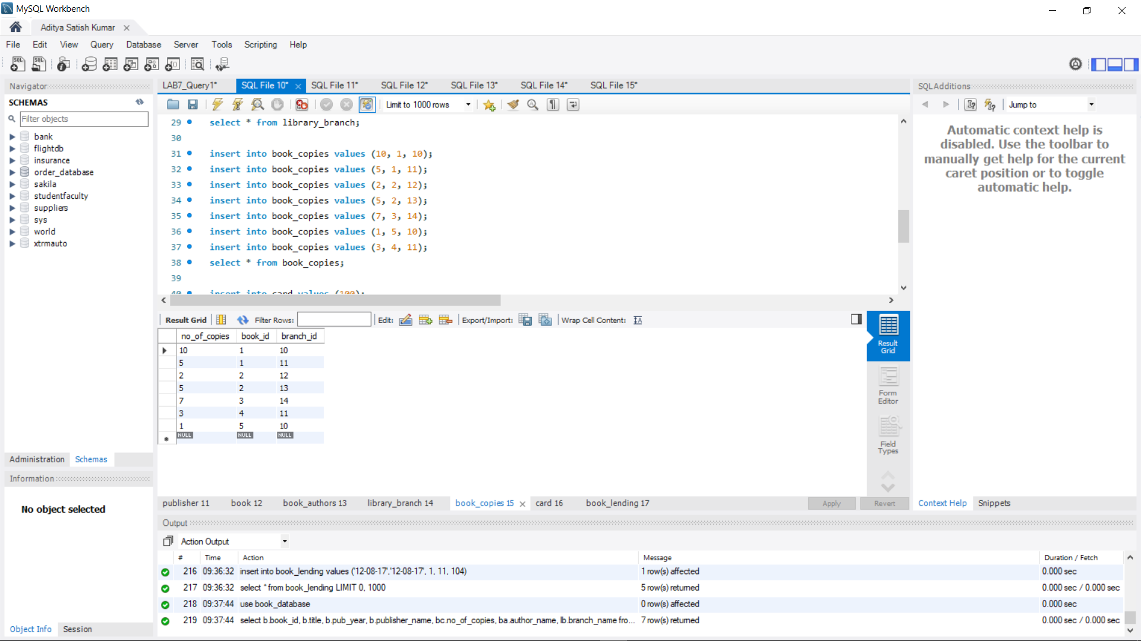

insert into card values (100);

insert into card values (101);

insert into card values (102);

insert into card values (103);

insert into card values (104);

select * from card;

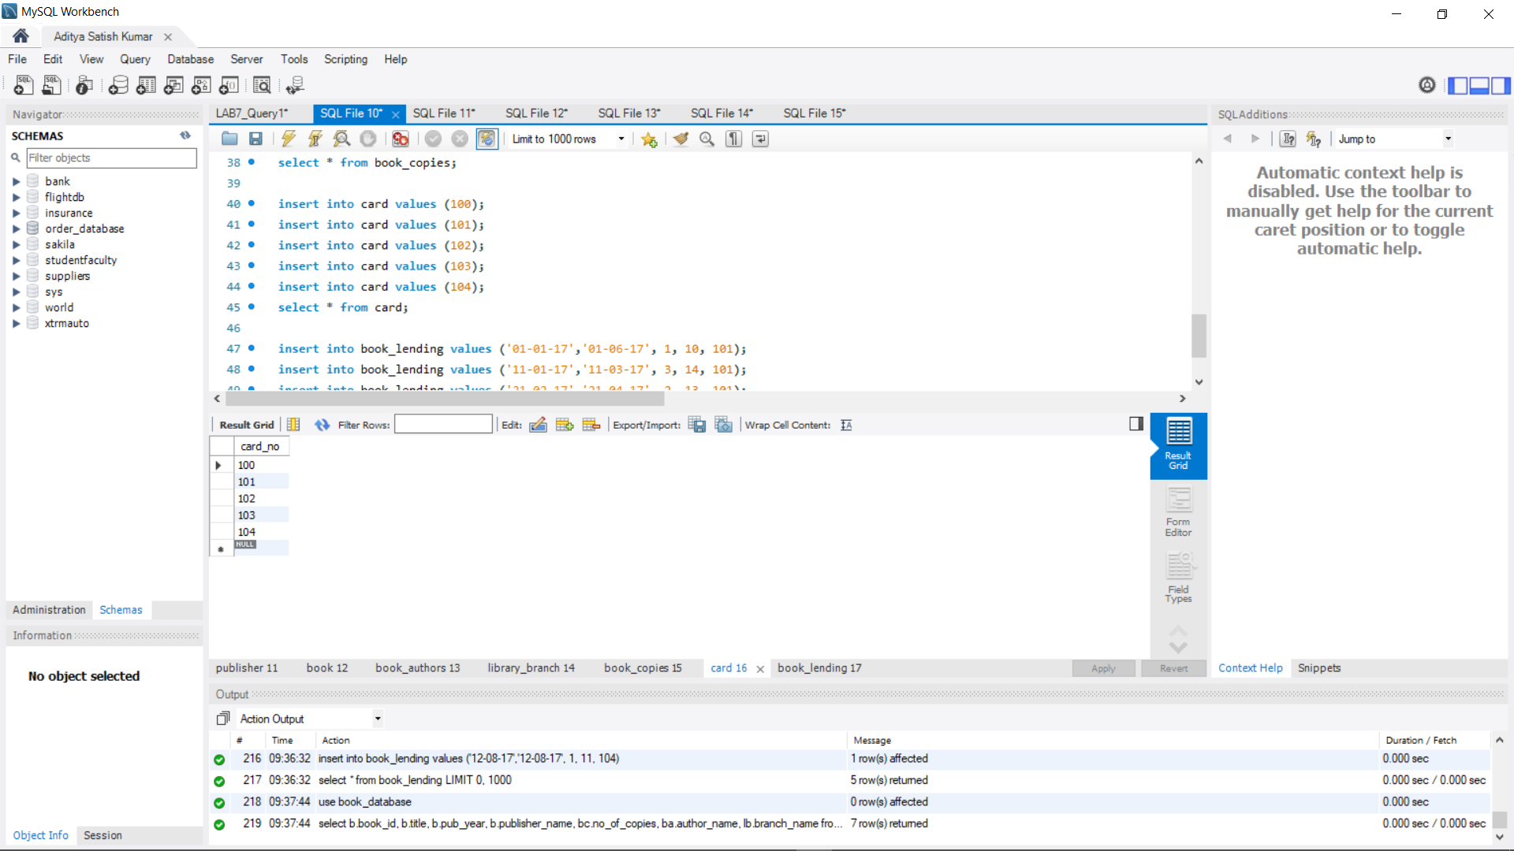

insert into book_lending values ('01-01-17','01-06-17', 1, 10, 101);

insert into book_lending values ('11-01-17','11-03-17', 3, 14, 101);

insert into book_lending values ('21-02-17','21-04-17', 2, 13, 101);

insert into book_lending values ('15-03-17','15-07-17', 4, 11, 101);

insert into book_lending values ('12-08-17','12-08-17', 1, 11, 104);

select * from book_lending;

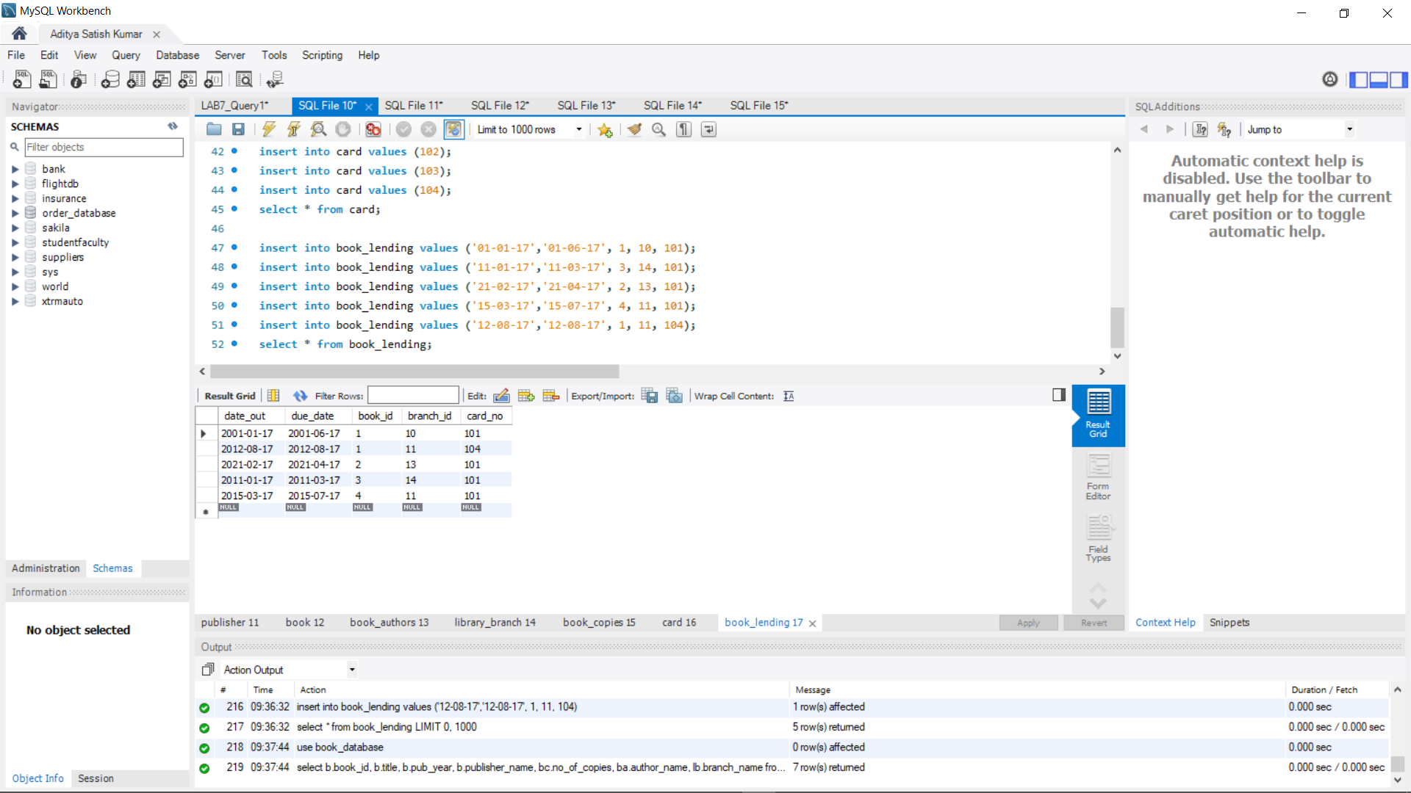

**QUERY 3**

use book_database;

select b.book_id, b.title, b.pub_year, b.publisher_name, bc.no_of_copies, ba.author_name, lb.branch_name from

book b, book_authors ba, library_branch lb, book_copies bc

where b.book_id = ba.book_id and

b.book_id = bc.book_id and

lb.branch_id = bc.branch_id;

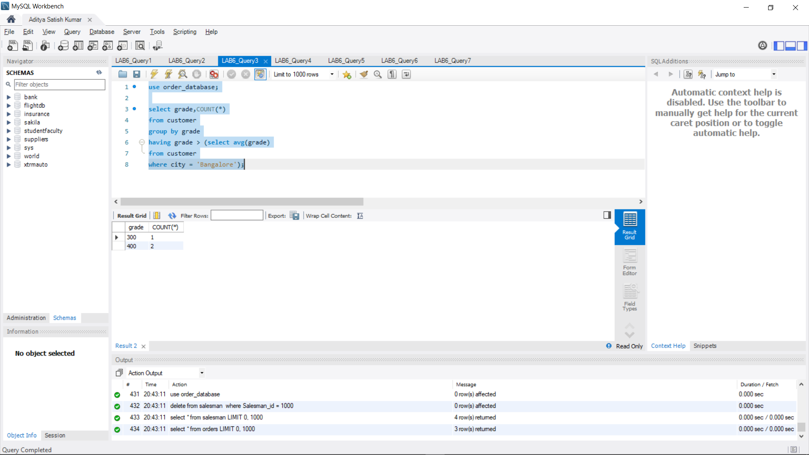

**QUERY 4**

use book_database;

select card_no

from book_lending

where year(date_out)>17 and month(date_out)<7

group by card_no having count(card_no)>2;

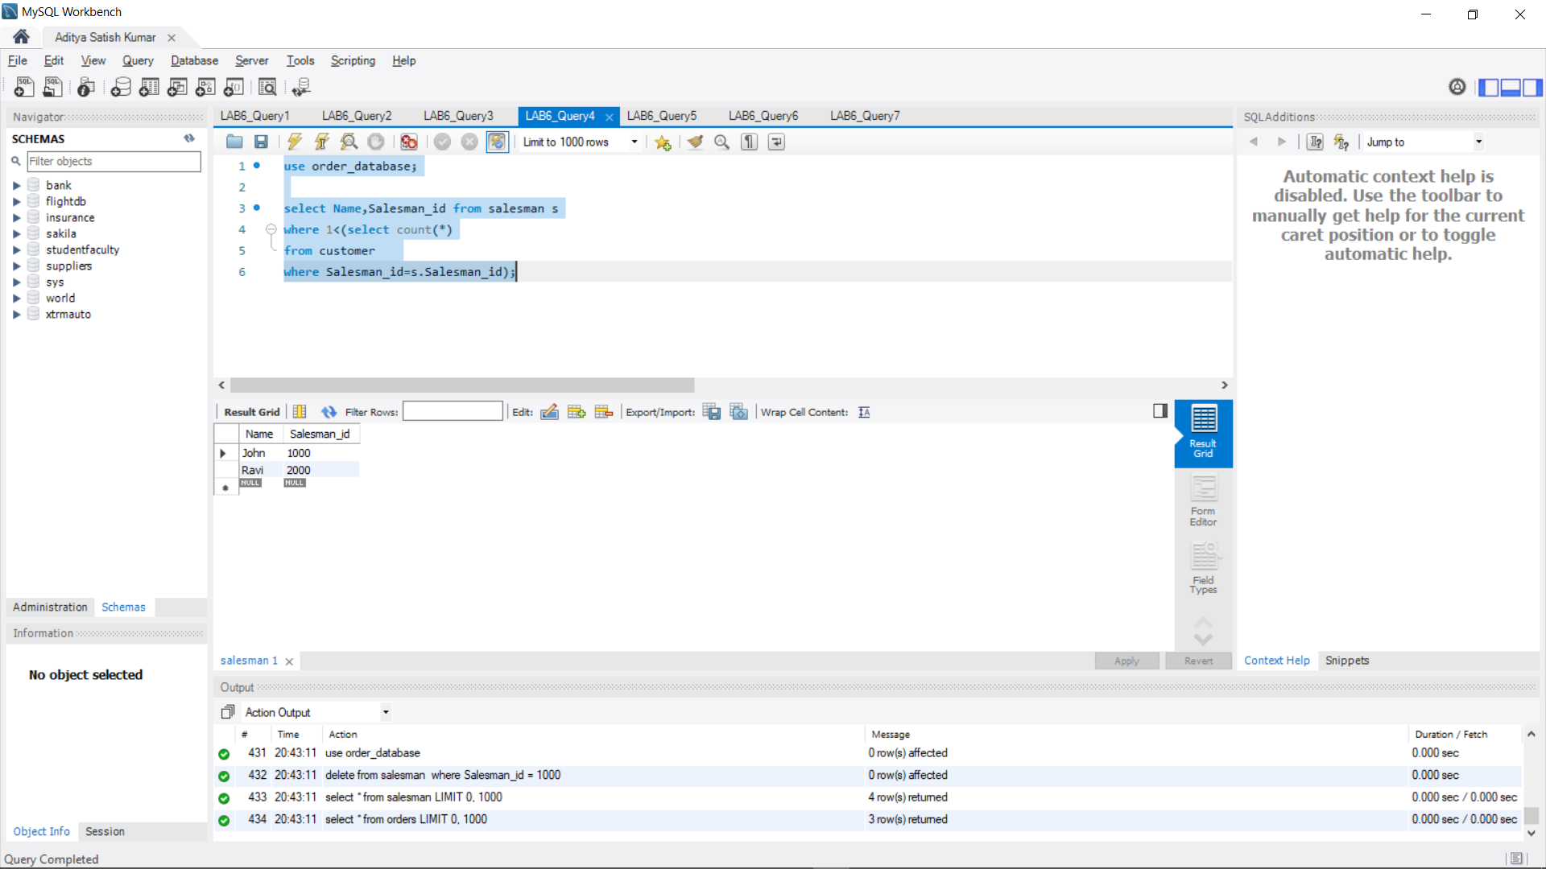

**QUERY 5**

use book_database;

delete from book where book_id = 3;

select * from book;

select * from book_authors;

select * from book_copies;

select * from book_lending;

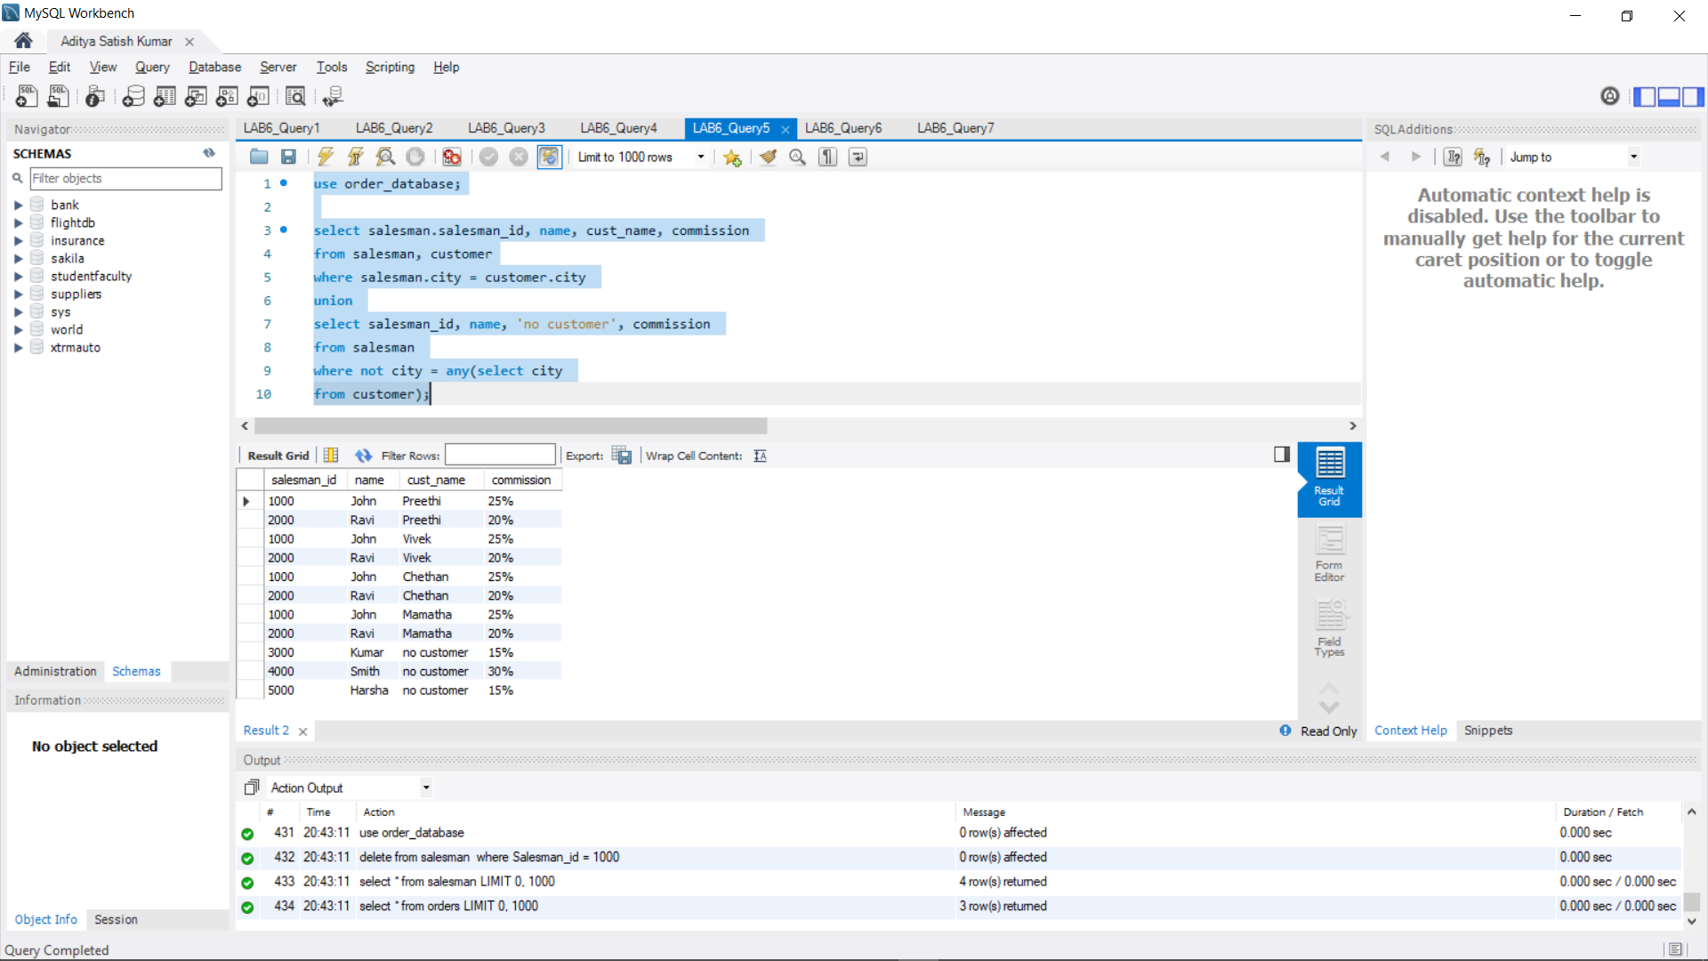

**QUERY 6**

use book_database;

create view view1

as select pub_year from book;

select * from view1;

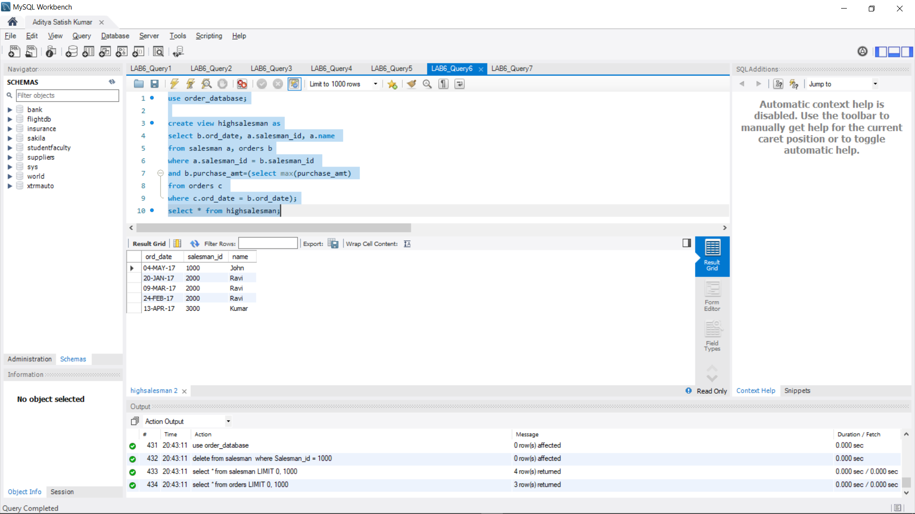

**QUERY 7**

use book_database;

create view view2

as select b.book_id, b.title, bc.no_of_copies from book b,book_copies bc

where b.book_id = bc.book_id;

select * from view2;

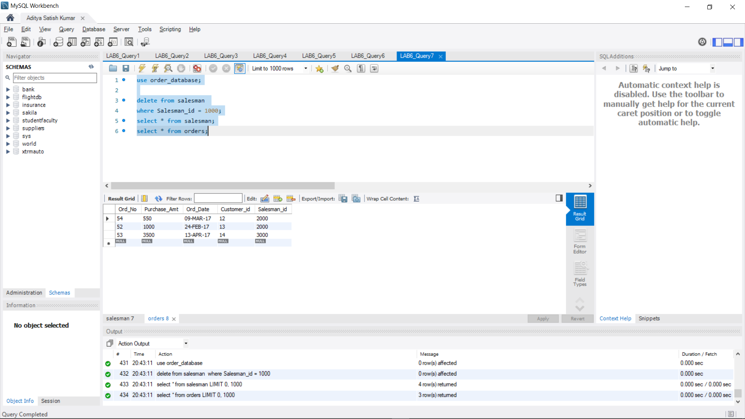

**PROGRAM 8: STUDENT ENROLLMENT**

Consider the following database of student enrollment in courses & books adopted for each course.

STUDENT (regno: string, name: string, major: string, bdate:date)

COURSE (course #:int, cname:string, dept:string)

ENROLL ( regno:string, course#:int, sem:int, marks:int)

BOOK _ ADOPTION (course# :int, sem:int, book-ISBN:int)

TEXT (book-ISBN:int, book-title:string, publisher:string, author:string)

Database applications laboratory GCEM DEPARTMENT OF CSE Page - 5 - 5th semester i. Create the above tables by properly specifying the primary keys and the foreign keys.

ii. Enter at least five tuples for each relation.

iii. Demonstrate how you add a new text book to the database and make this book be adopted by some department.

iv. Produce a list of text books (include Course #, Book-ISBN, Book-title) in the alphabetical order for courses offered by the ‘CS’ department that use more than two books.

v. List any department that has all its adopted books published by a specific publisher.

vi. Generate suitable reports.

vii. Create suitable front end for querying and displaying the results.

**QUERY 1**

create database StudentEnrollment;

use STudentEnrollment;

create table student(

regno varchar(20),

name varchar(30),

major varchar(20),

bdate date,

primary key (regno)

);

create table course(

courseno int,

cname varchar(20),

dept varchar(20),

primary key (courseno)

);

create table enroll(

regno varchar(20),

courseno int,

sem int,

marks int,

primary key (regno,courseno),

foreign key (regno) references student (regno),

foreign key (courseno) references course (courseno)

);

create table text(

book_isbn int,

book_title varchar(30),

publisher varchar(30),

author varchar(30),

primary key (book_isbn)

);

create table book_adoption(

courseno int,

sem int,

book_isbn int,

primary key (courseno,book_isbn),

foreign key (courseno) references course (courseno),

foreign key (book_isbn) references text(book_isbn)

);

**QUERY 2**

use studentenrollment;

insert into student values('1PE11CS002','b','SR','19930924');

insert into student values('1PE11CS003','c','SR','19931127');

insert into student values('1PE11CS004','d','SR','19930413');

insert into student values('1PE11CS005','e','JR','19940824');

select * from student;

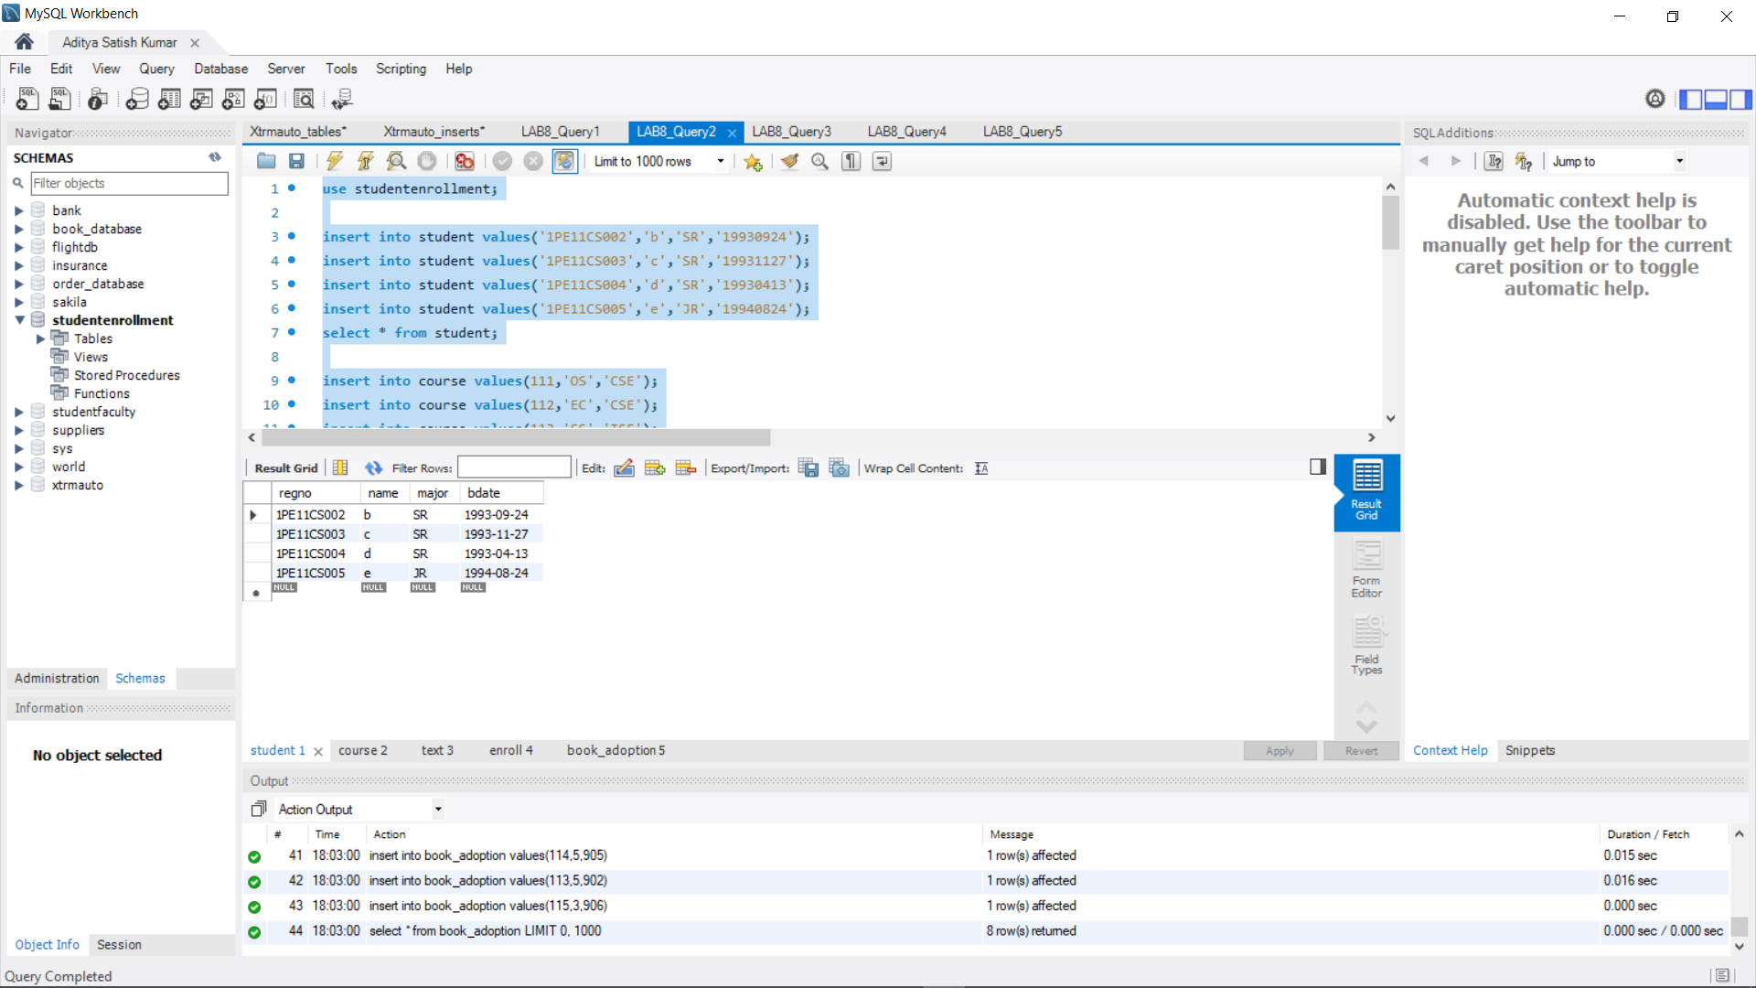

insert into course values(111,'OS','CSE');

insert into course values(112,'EC','CSE');

insert into course values(113,'SS','ISE');

insert into course values (114,'DBMS','CSE');

insert into course values (115,'SIGNALS','ECE');

select * from course;

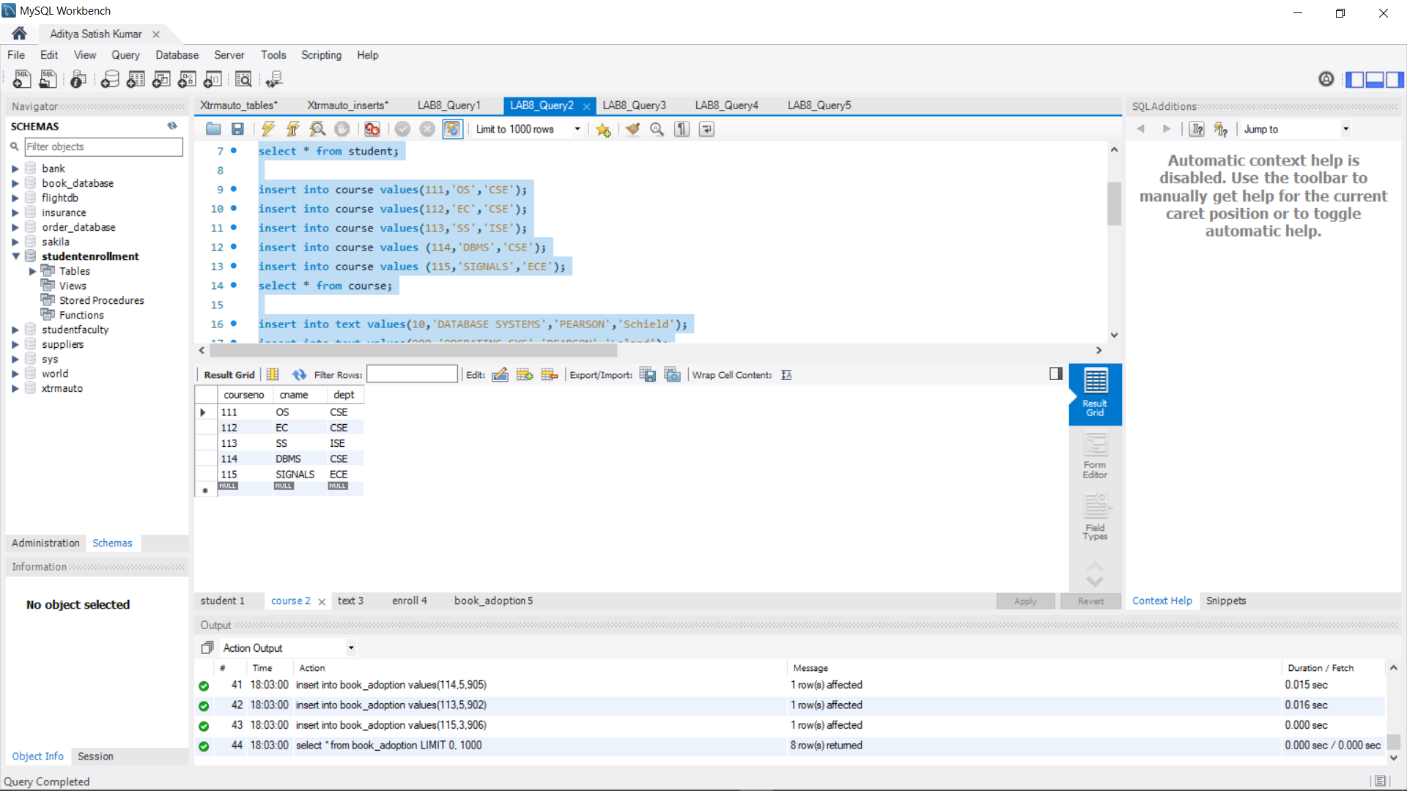

insert into text values(10,'DATABASE SYSTEMS','PEARSON','Schield');

insert into text values(900,'OPERATING SYS','PEARSON','Leland');

insert into text values(901,'CIRCUITS','HALL INDIA','Bob');

insert into text values(902,'SYSTEM SOFTWARE','peterson','Jacob');

insert into text values(903,'SCHEDULING','PEARSON','Patil');

insert into text values(904,'DATABASE SYSTEMS','PEARSON','Jacob');

insert into text values(905,'DATABASE MANAGER','PEARSON','Bob');

insert into text values(906,'SIGNALS','HALL INDIA','Sumit');

select * from text;

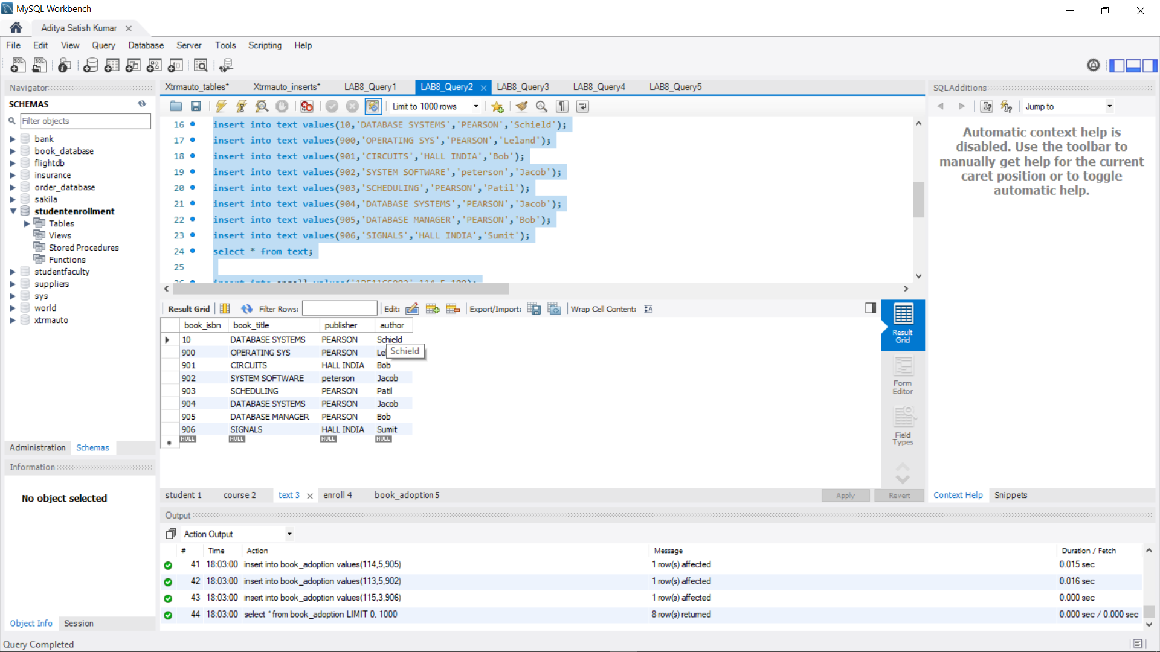

insert into enroll values('1PE11CS002',114,5,100);

insert into enroll values('1PE11CS003',113,5,100);

insert into enroll values('1PE11CS004',111,5,100);

insert into enroll values('1PE11CS005',112,3,100);

select * from enroll;

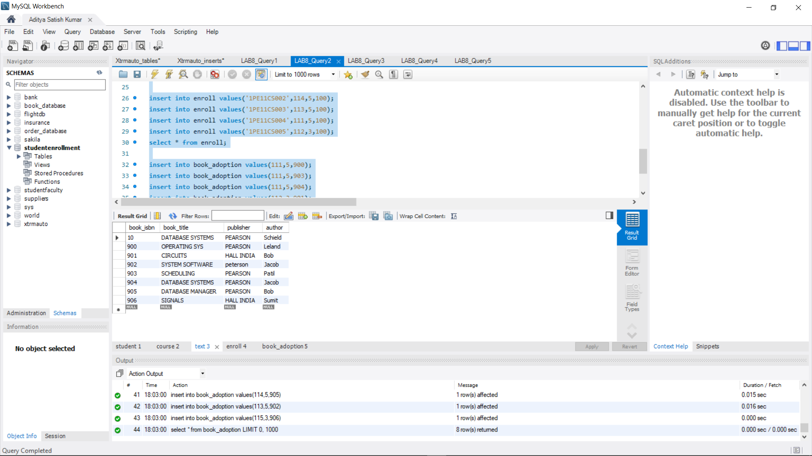

insert into book_adoption values(111,5,900);

insert into book_adoption values(111,5,903);

insert into book_adoption values(111,5,904);

insert into book_adoption values(112,3,901);

insert into book_adoption values(113,3,10);

insert into book_adoption values(114,5,905);

insert into book_adoption values(113,5,902);

insert into book_adoption values(115,3,906);

select * from book_adoption;

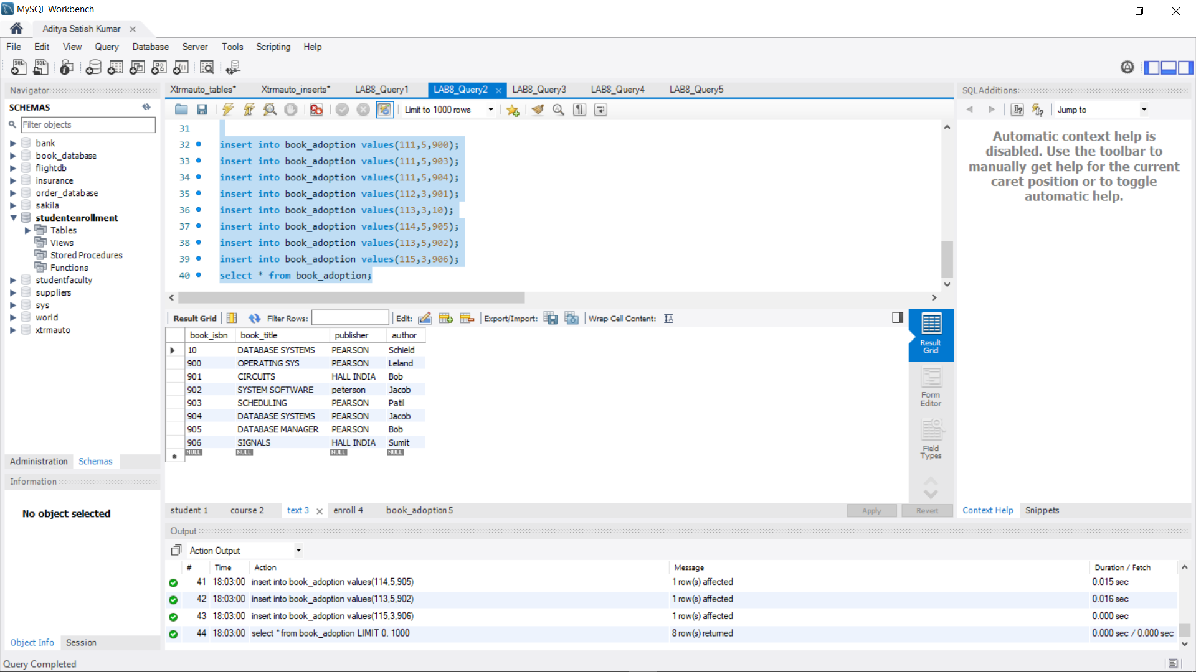

**QUERY 3**

use studentenrollment;

insert into text values (907,'ai','HALL INDIA','Sumit');

insert into book_adoption values(115, 2, 907);

select * from text;

select * from book_adoption;

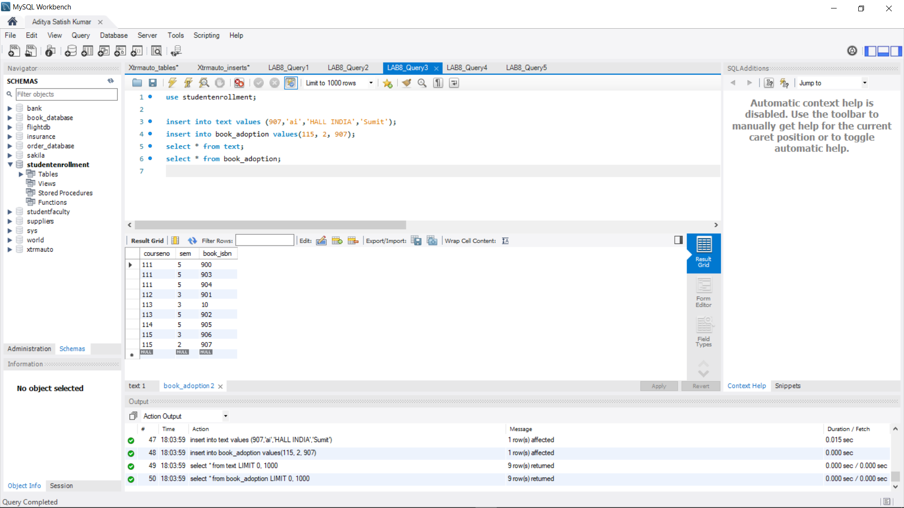

**QUERY 4**

use studentenrollment;

select b.book_isbn, b.courseno, t.book_title from book_adoption b,text t

where t.book_isbn = b.book_isbn

and b.courseno in(select

courseno from course

where dept = 'CSE'

and courseno in (select

courseno from book_adoption

group by courseno having count(*)>2));

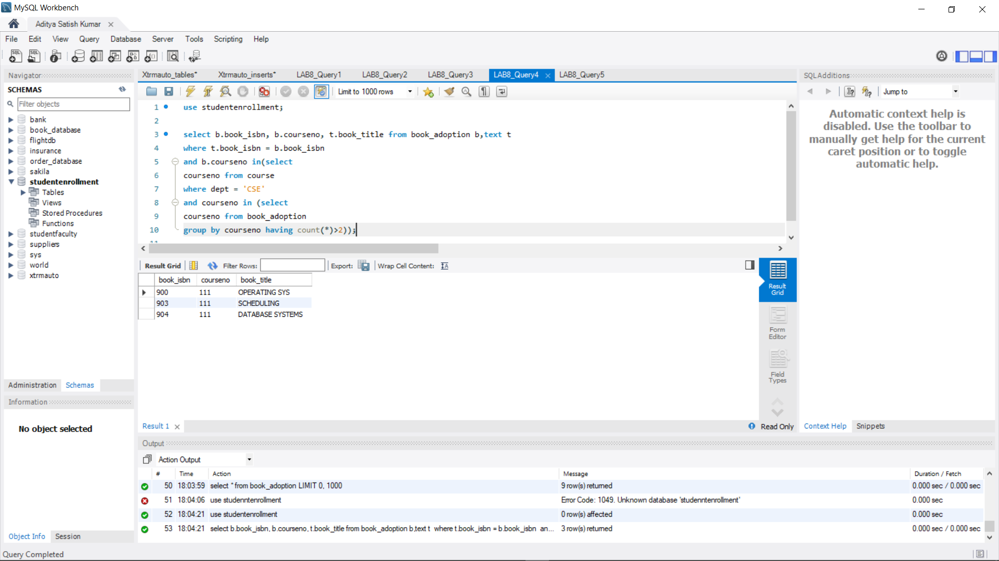

**QUERY 5**

use studentenrollment;

select distinct c.dept from course c

where c.dept in(select c.dept

from course c,book_adoption b,text t

where c.courseno=b.courseno

and t.book_isbn=b.book_isbn

and t.publisher='HALL INDIA')

and c.dept not in(select c.dept

from course c,book_adoption b,text t

where c.courseno=b.courseno

and t.book_isbn=b.book_isbn

and t.publisher != 'HALL INDIA');

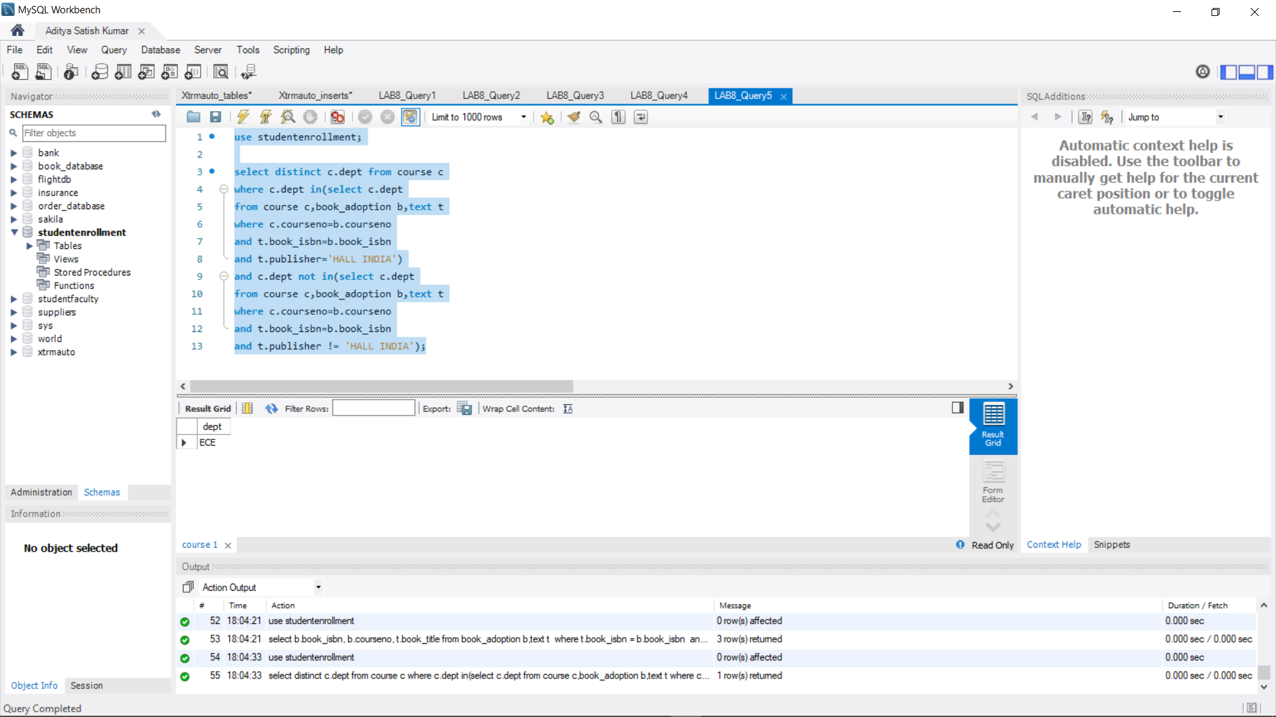

**PROGRAM 9: MOVIE DATABASE**

**Consider the schema for Movie Database:**

**ACTOR (*Act_id, Act_Name, Act_Gender*)**

**DIRECTOR (*Dir_id, Dir_Name, Dir_Phone*)**

**MOVIES (*Mov_id, Mov_Title, Mov_Year, Mov_Lang, Dir_id*)**

**MOVIE_CAST (*Act_id, Mov_id, Role*)**

**RATING (*Mov_id, Rev_Stars*)**

**Write SQL queries to**

**1. List the titles of all movies directed by ‘Hitchcock’.**

**2. Find the movie names where one or more actors acted in two or more movies.**

**3. List all actors who acted in a movie before 2000 and also in a movie after**

**2015 (use JOIN operation).**

**4. Find the title of movies and number of stars for each movie that has at least one rating and find the highest number of stars that movie received. Sort the result by movie title.**

**5. Update rating of all movies directed by ‘Steven Spielberg’ to 5.**

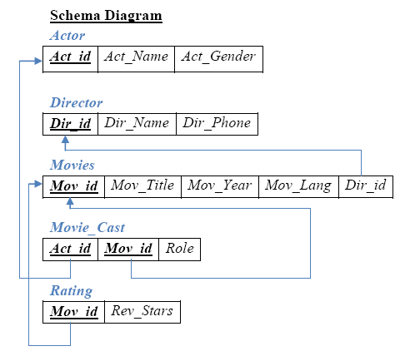

**QUERY 1**

create database movie_database;

use movie_database;

create table actor(

act_id int,

act_name varchar(30),

act_gender enum('M','F'),

primary key(act_id));

create table director(

dir_id int,

dir_name varchar(30),

dir_phone varchar(10),

primary key(dir_id));

create table movies(

mov_id int,

mov_title varchar(30),

mov_year year,

mov_lang varchar(10),

dir_id int,

primary key(mov_id),

foreign key(dir_id) references director(dir_id) on delete cascade);

create table moviecast(

act_id int,

mov_id int,

part varchar(20),

primary key(act_id, mov_id),

foreign key(act_id) references actor(act_id) on delete cascade,

foreign key(mov_id) references movies(mov_id) on delete cascade);

create table rating(

mov_id int,

rev_stars float,

primary key(mov_id, rev_stars),

foreign key(mov_id) references movies(mov_id) on delete cascade);

**QUERY 2**

use movie_database;

insert into actor values(100, "Leonardo DiCaprio", 'M');

insert into actor values(101, "Tom Hanks", 'M');

insert into actor values(102, "Tom Cruise", 'M');

insert into actor values(103, "Margot Robbie", 'F');

insert into actor values(104, "Jennifer Aniston", 'F');

insert into actor values(105, "Gal Gadot", 'F');

select * from actor;

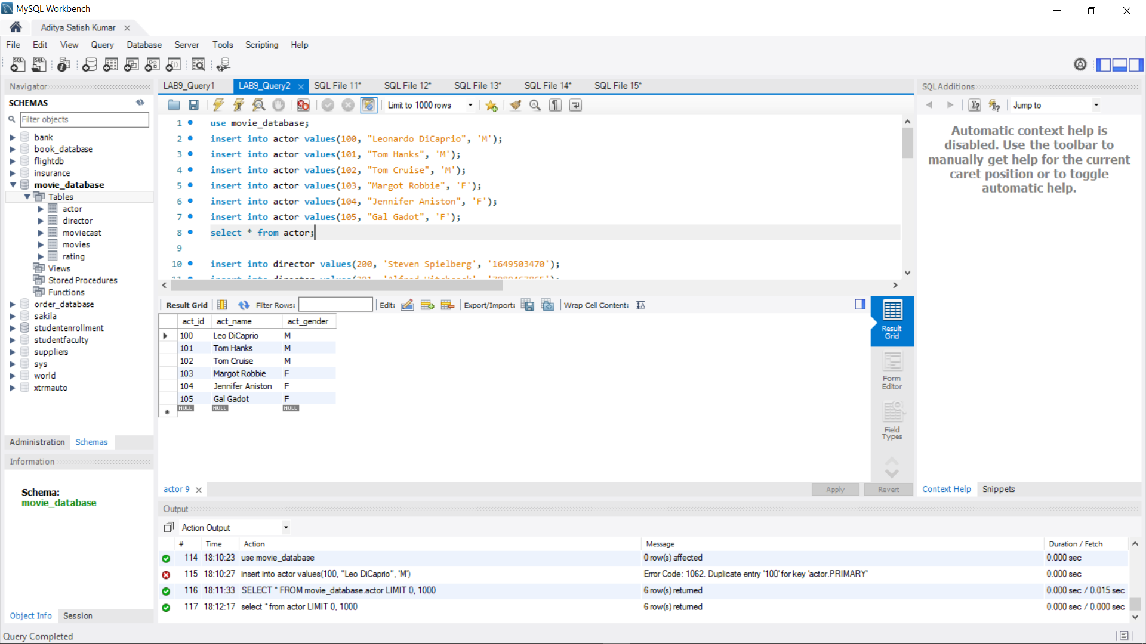

insert into director values(200, 'Steven Spielberg', '1649503470');

insert into director values(201, 'Alfred Hitchcock', '7989467865');

insert into director values(202, 'James Cameron', '5218281077');

insert into director values(203, 'Kathryn Bigelow', '6157228013');

insert into director values(204, 'Niki Caro', '8976600547');

insert into director values(205, 'Sofia Coppola', '3949875040');

select * from director;

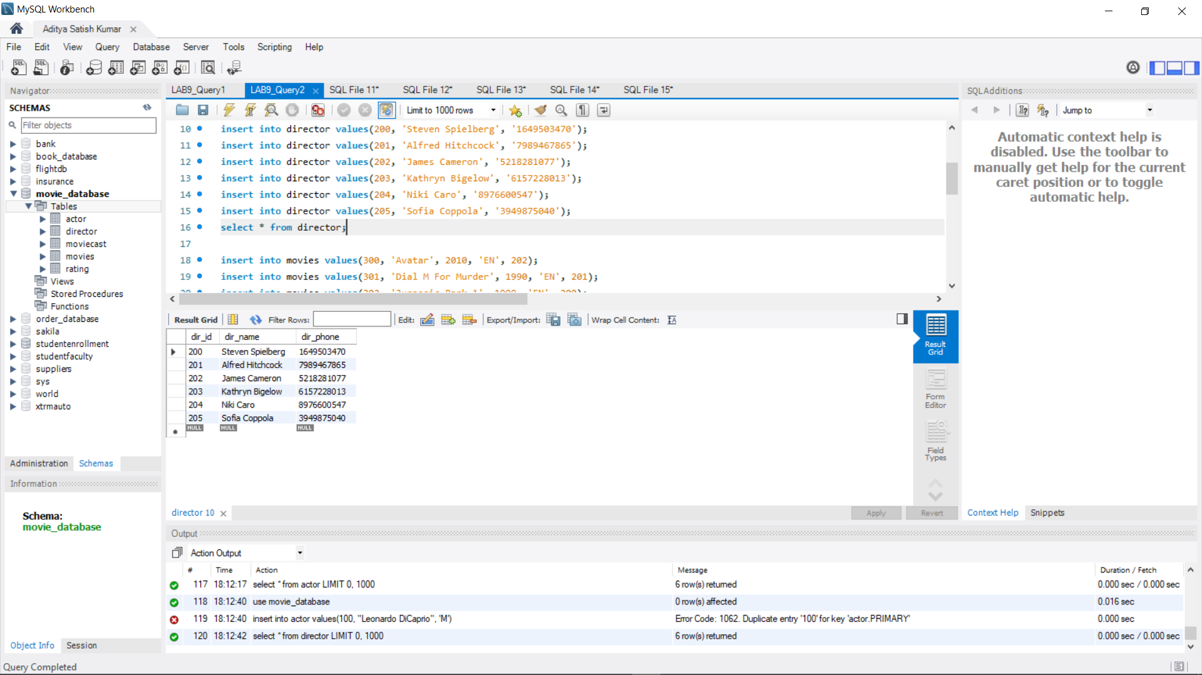

insert into movies values(300, 'Avatar', 2010, 'EN', 202);

insert into movies values(301, 'Dial M For Murder', 1990, 'EN', 201);

insert into movies values(302, 'Jurassic Park 1', 1999, 'EN', 200);

insert into movies values(303, 'Jurassic Park 2', 2017, 'EN', 200);

insert into movies values(304, 'Vertigo', 1986, 'EN', 201);

insert into movies values(305, 'Zero Dark Thirty', 2012, 'EN', 200);

select * from movies;

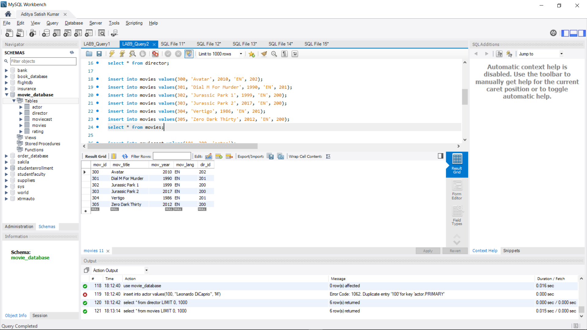

insert into moviecast values(101, 300, 'actor');

insert into moviecast values(105, 300, 'actress');

insert into moviecast values(102, 301, 'actor');

insert into moviecast values(103, 301, 'actress');

insert into moviecast values(100, 302, 'actor');

insert into moviecast values(104, 302, 'actress');

insert into moviecast values(100, 303, 'actor');

insert into moviecast values(104, 303, 'actress');

insert into moviecast values(102, 304, 'actor');

insert into moviecast values(105, 304, 'actress');

insert into moviecast values(103, 305, 'actress');

select * from moviecast;

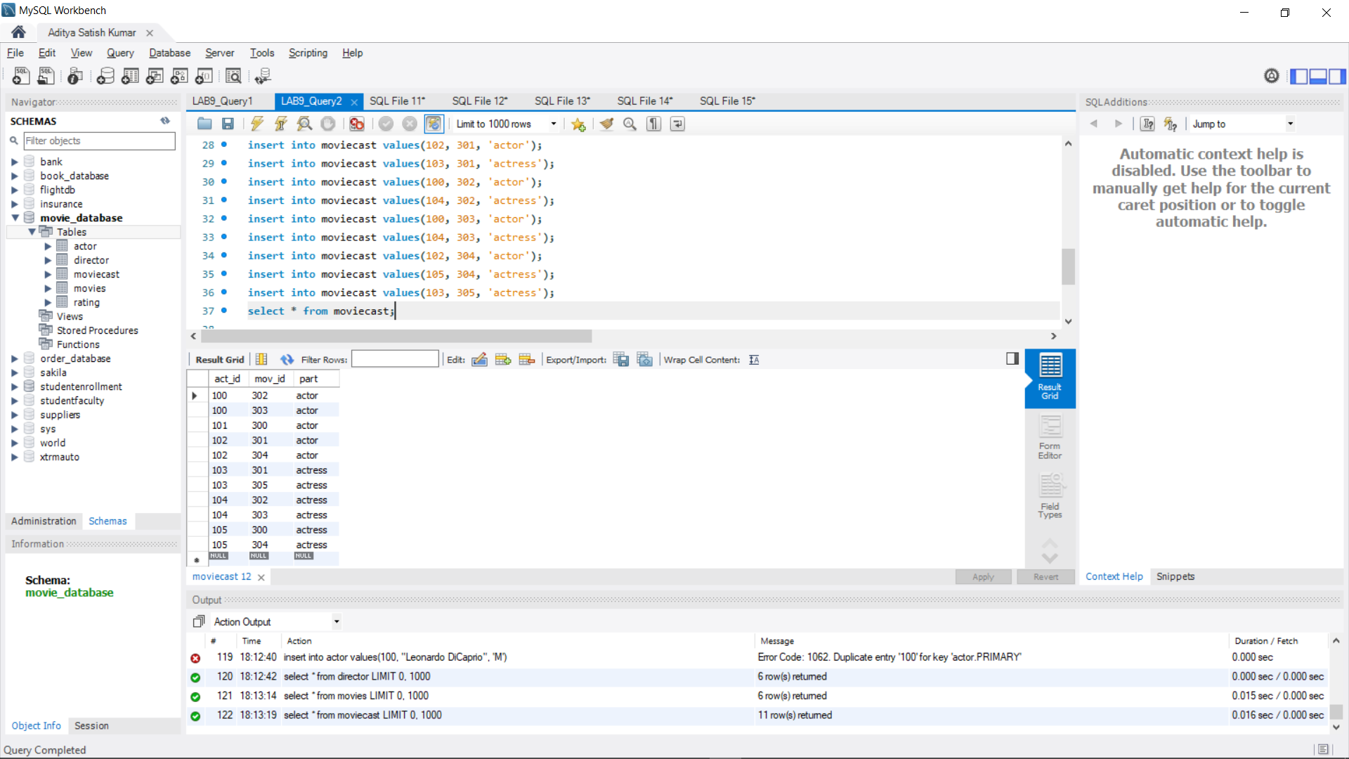

insert into rating values(300, 4.5);

insert into rating values(301, 3);

insert into rating values(302, 4);

insert into rating values(303, 3.5);

insert into rating values(304, 5);

insert into rating values(305, 4);

select * from rating;

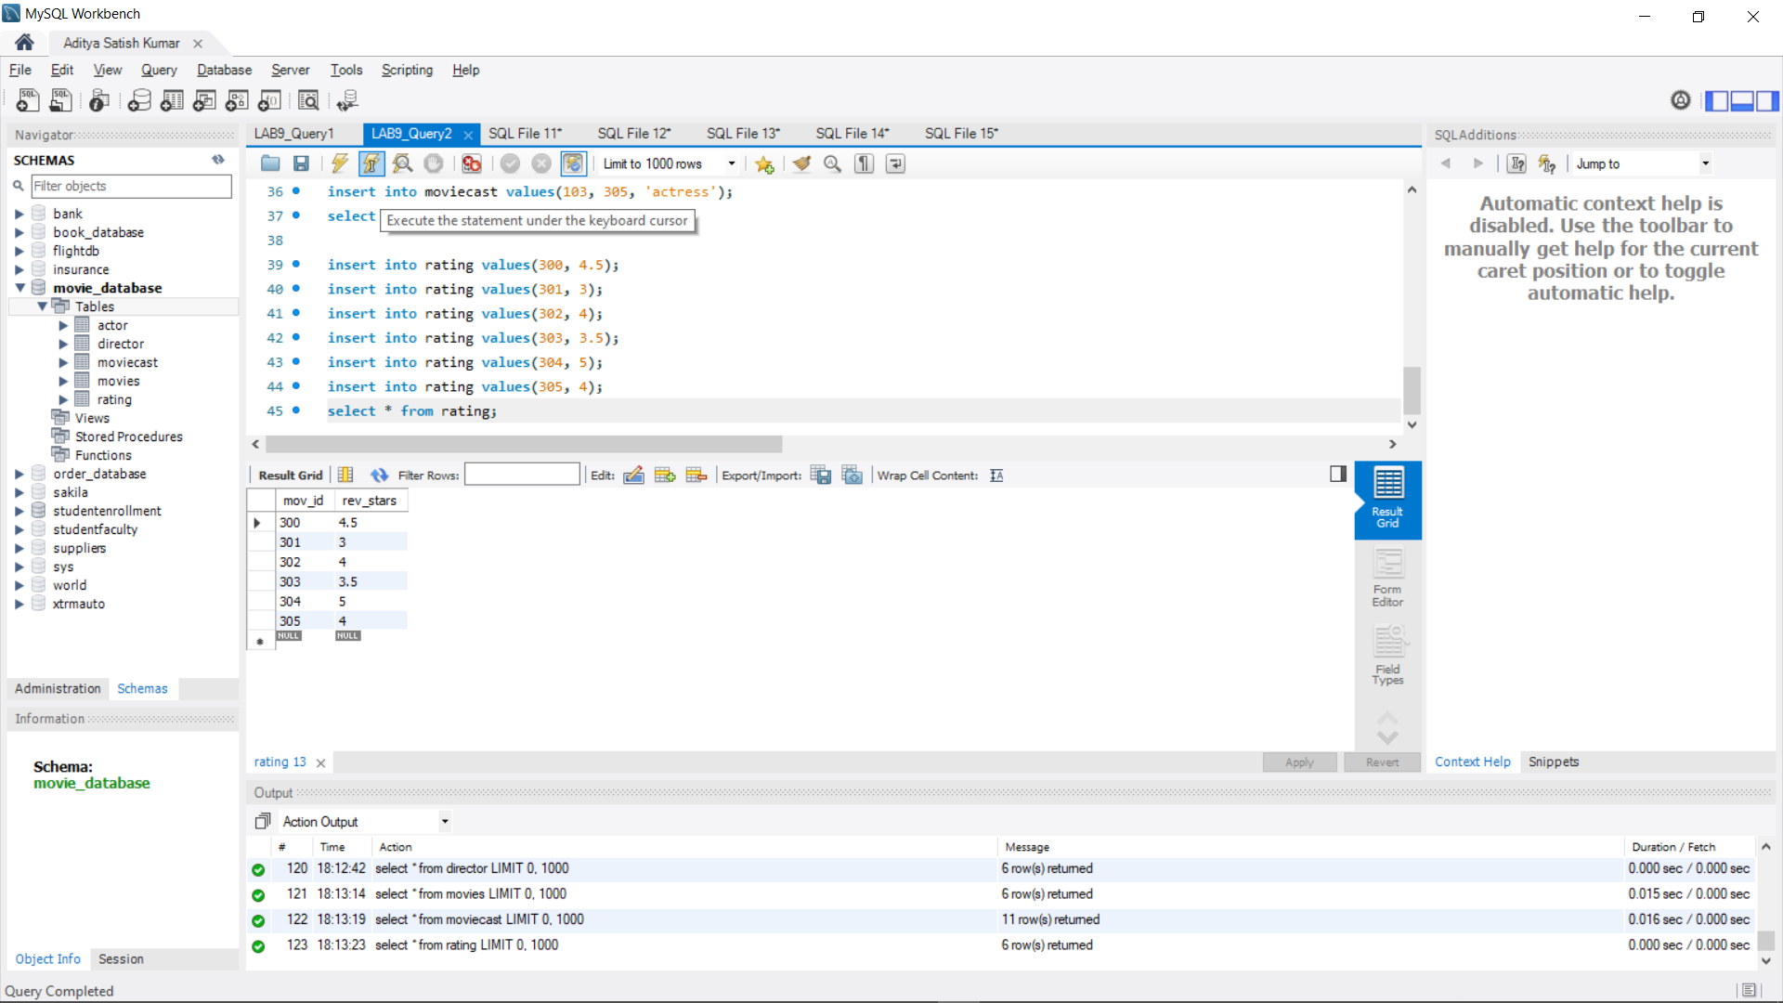

**QUERY 3**

select m.mov_title from movies m, director d

where m.dir_id=d.dir_id

and d.dir_name='Alfred Hitchcock';

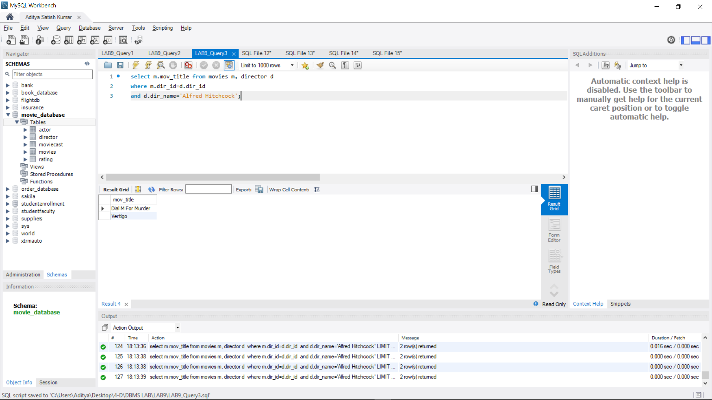

**QUERY 4**

select m.mov_title from movies m, moviecast mc

where m.mov_id=mc.mov_id

and act_id in(

select act_id from moviecast

group by act_id

having count(act_id) > 1)

group by m.mov_title having count(*) >= 2;

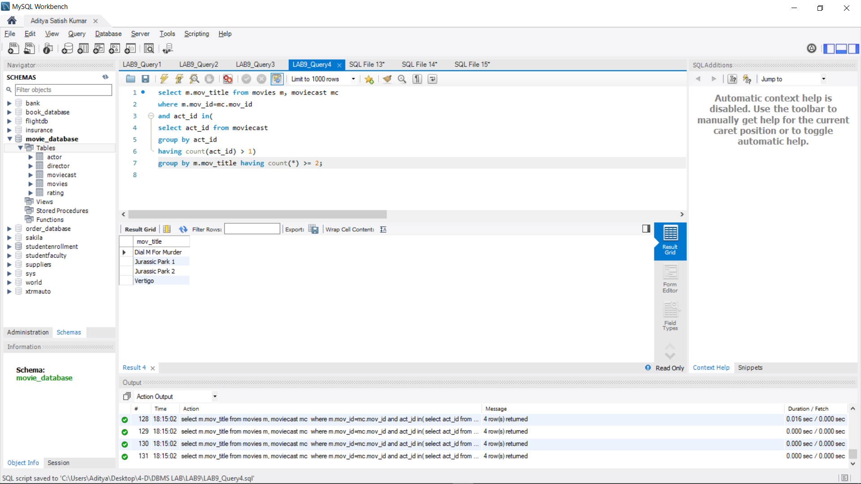

**QUERY 5**

select a.act_name, m.mov_title, m.mov_year

from actor a, movies m, moviecast mc

where a.act_id=mc.act_id

and mc.mov_id=m.mov_id

and m.mov_year not between 2000 and 2015;

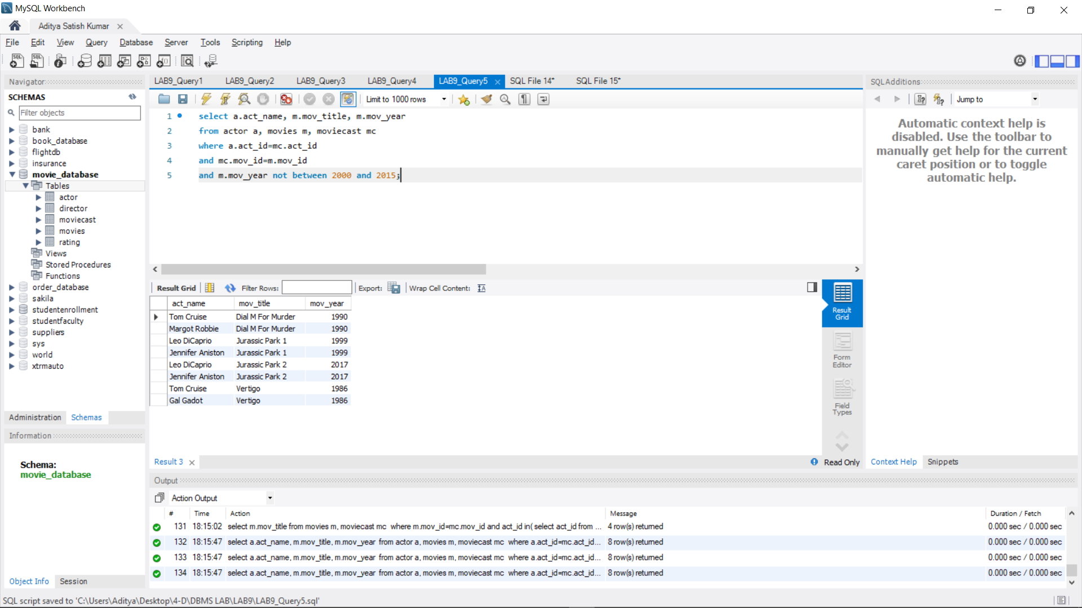

**QUERY 6**

select mov_title, max(rev_stars)

from movies inner join rating using (mov_id)

group by mov_title

having max(rev_stars)>0

order by mov_title;

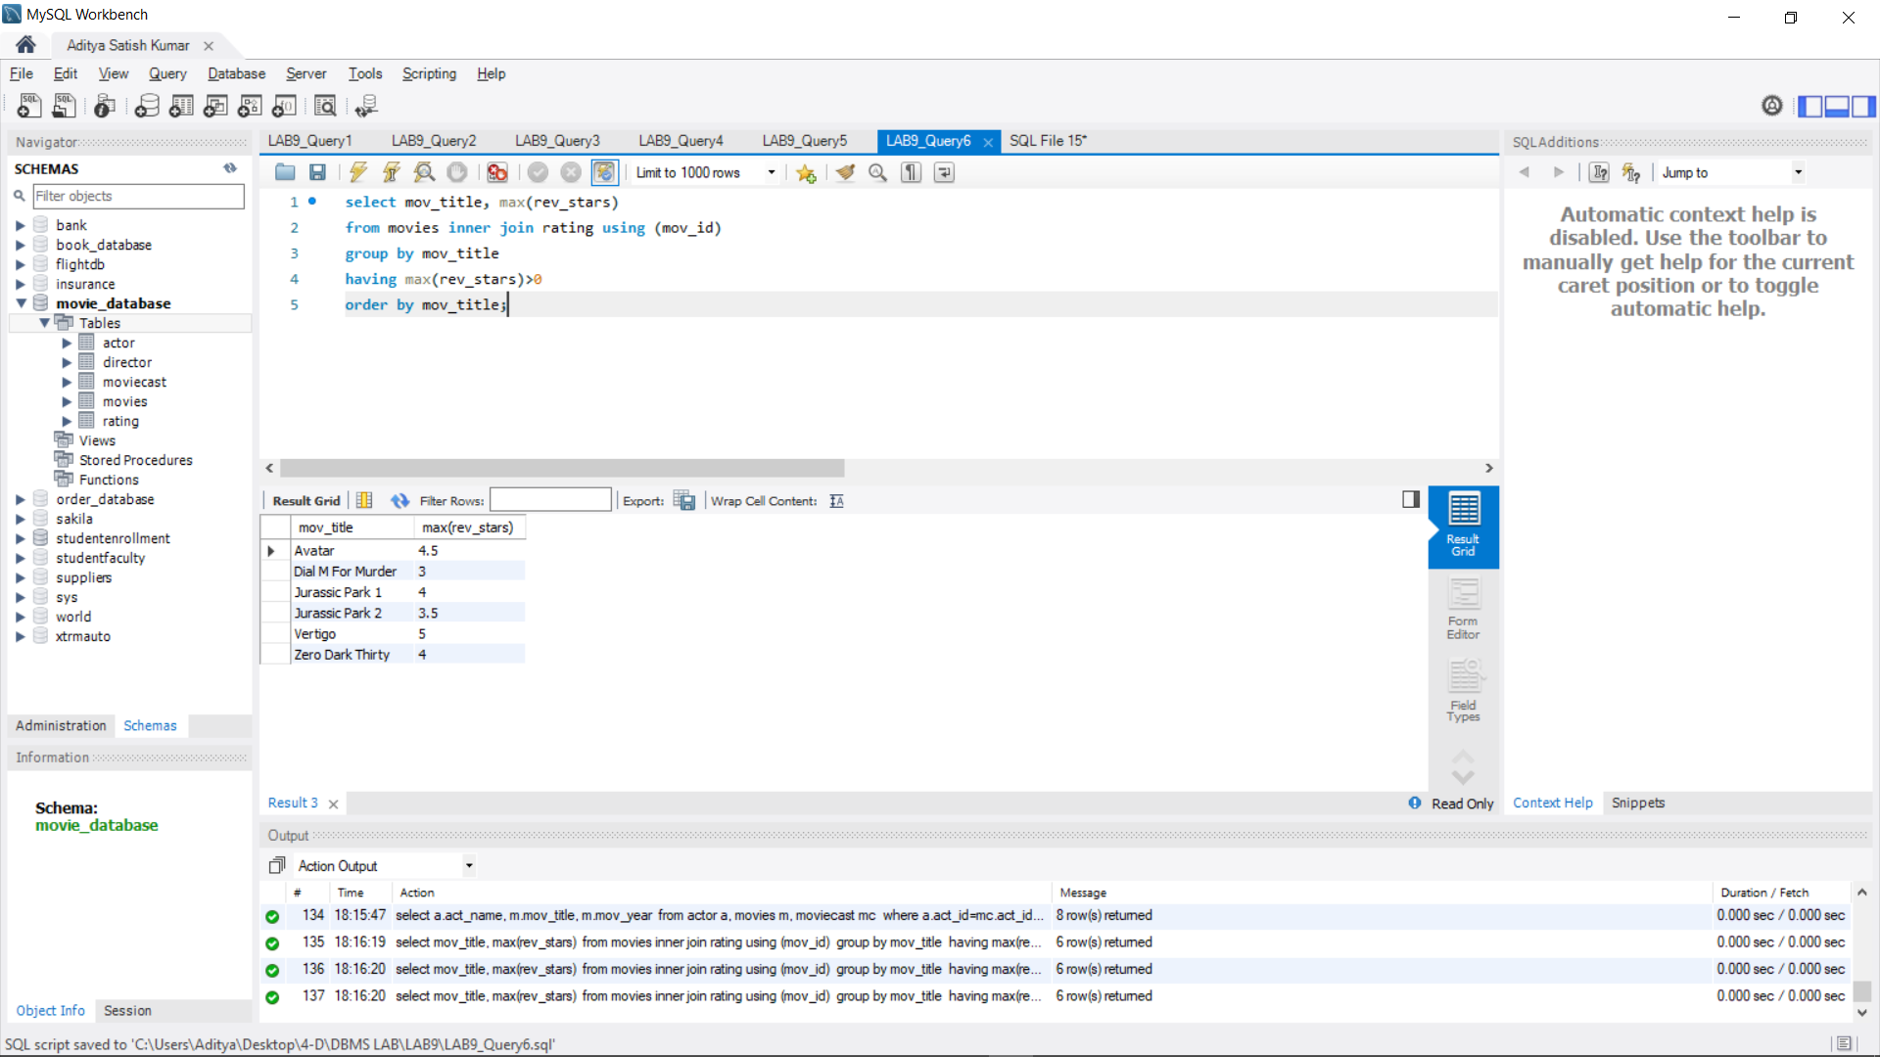

**QUERY 7**

update rating set rev_stars = 5

where mov_id in (

select mov_id from movies

where dir_id in(

select dir_id from director

where dir_name='Steven Spielberg'));

select * from rating;

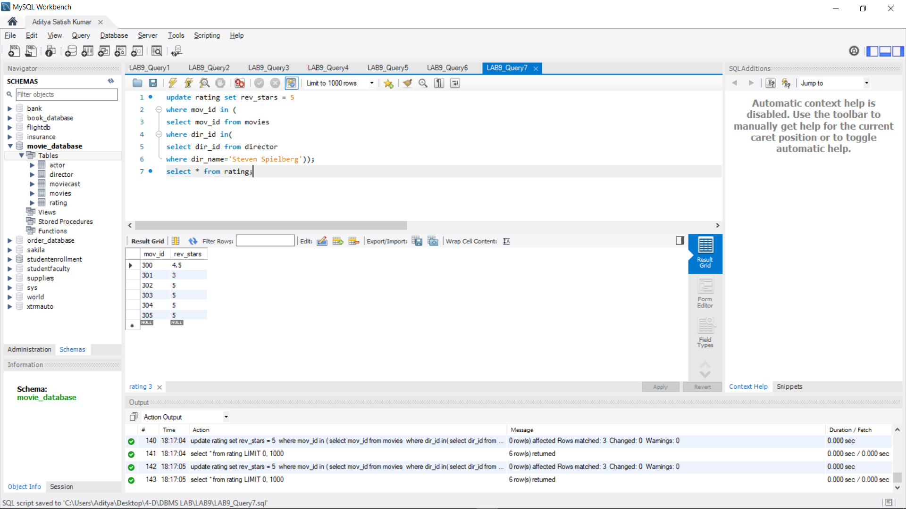

**PROGRAM 10: COLLEGE DATABASE**

Consider the schema for College Database:

STUDENT (USN, SName, Address, Phone, Gender)

SEMSEC (SSID, Sem, Sec)

CLASS (USN, SSID)

SUBJECT (Subcode, Title, Sem, Credits)

IAMARKS (USN, Subcode, SSID, Test1, Test2, Test3, FinalIA)

Write SQL queries to

1. List all the student details studying in fourth semester ‘C’ section.

2. Compute the total number of male and female students in each semester and in each section.

3. Create a view of Test1 marks of student USN ‘1BI15CS101’ in all subjects.

4. Categorize students based on the following criterion:

**If FinalIA = 17 to 20 then CAT = ‘Outstanding’**

**If FinalIA = 12 to 16 then CAT = ‘Average’**

**If FinalIA< 12 then CAT = ‘Weak’**

**Give these details only for 8th semester A, B, and C section students.**

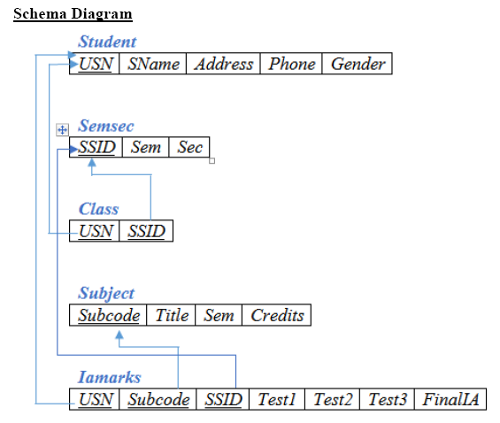

**QUERY 1**

create database college_database;

use college_database;

create table student(

usn varchar(30),

sname varchar(30),

address varchar(30),

phone real,

gender varchar(30),

primary key(usn));

create table semsec(

ssid varchar(30),

sem int,

sec varchar(30),

primary key(ssid));

create table class(

usn varchar(30),

ssid varchar(30),

primary key(usn,ssid),

foreign key(usn) references student(usn),

foreign key(ssid) references semsec(ssid));

create table subject(

code varchar(30),

title varchar(30),

sem int,

credits int,

primary key(code));

create table marks(

usn varchar(30),code varchar(30),

ssid varchar(30),

test1 real,

test2 real,

test3 real,

final real,

primary key(usn,code,ssid),

foreign key(usn) references student(usn),

foreign key(code) references subject(code),

foreign key(ssid) references semsec(ssid));

**QUERY 2**

use college_database;

insert into student values('1RN13CS020','akshay','belagavi',8877881122,'m'),

('1RN13CS062','sandhya','bengaluru',7722829912,'f'),

('1RN13CS091','teesha','bengaluru',7712312312,'f'),

('1RN13CS066','supriya','mangaluru',8877881122,'f'),

('1RN14CS010','abhay','bengaluru',9900211201,'m'),

('1RN14CS032','bhaskar','bengaluru',9923211099,'m'),

('1RN14CS025','asmi','bengaluru',7894737377,'f'),

('1RN15CS011','ajay','tumkur',98545091341,'m'),

('1RN15CS029','chitra','davangere',7696772121,'f'),

('1RN15CS045','jeeva','bellary',9944850121,'m'),

('1RN15CS091','santosh','mangaluru',8812332201,'m'),

('1RN16CS045','ismail','kalburgi',9900232201,'m'),

('1RN16CS088','sameera','shimoga',9905542212,'f'),

('1RN16CS122','vinayaka','chikamagaluru',8800880011,'m');

select * from student;

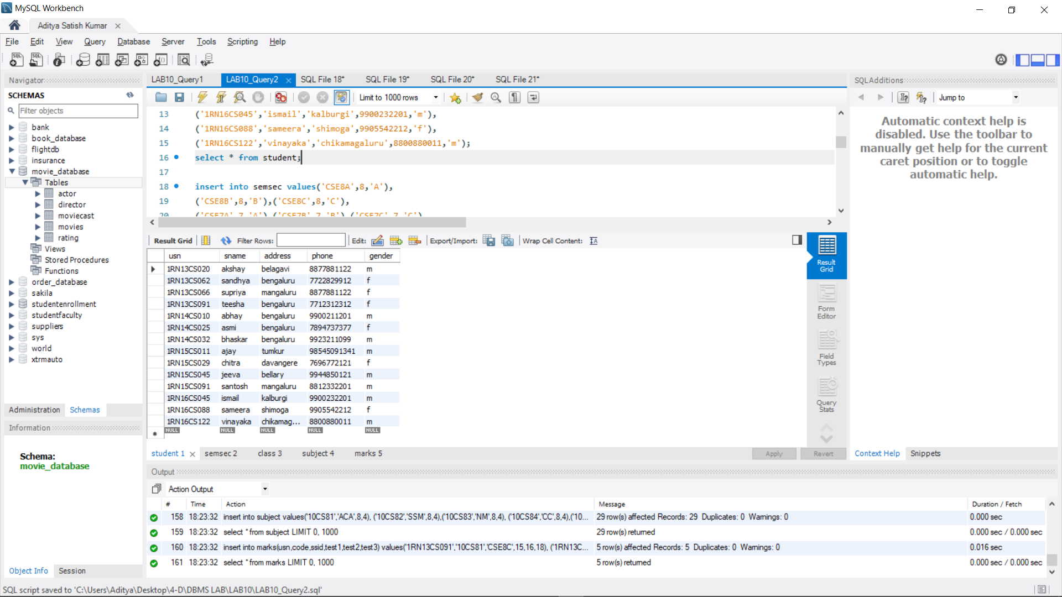

insert into semsec values('CSE8A',8,'A'),

('CSE8B',8,'B'),('CSE8C',8,'C'),

('CSE7A',7,'A'),('CSE7B',7,'B'),('CSE7C',7,'C'),

('CSE6A',6,'A'),('CSE6B',6,'B'),('CSE6C',6,'C'),

('CSE5A',5,'A'),('CSE5B',5,'B'),('CSE5C',5,'C'),

('CSE4A',4,'A'),('CSE4B',4,'B'),('CSE4C',4,'C'),

('CSE3A',3,'A'),('CSE3B',3,'B'),('CSE3C',3,'C'),

('CSE2A',2,'A'),('CSE2B',2,'B'),('CSE2C',2,'C'),

('CSE1A',1,'A'),('CSE1B',1,'B'),('CSE1C',1,'C');

select * from semsec;

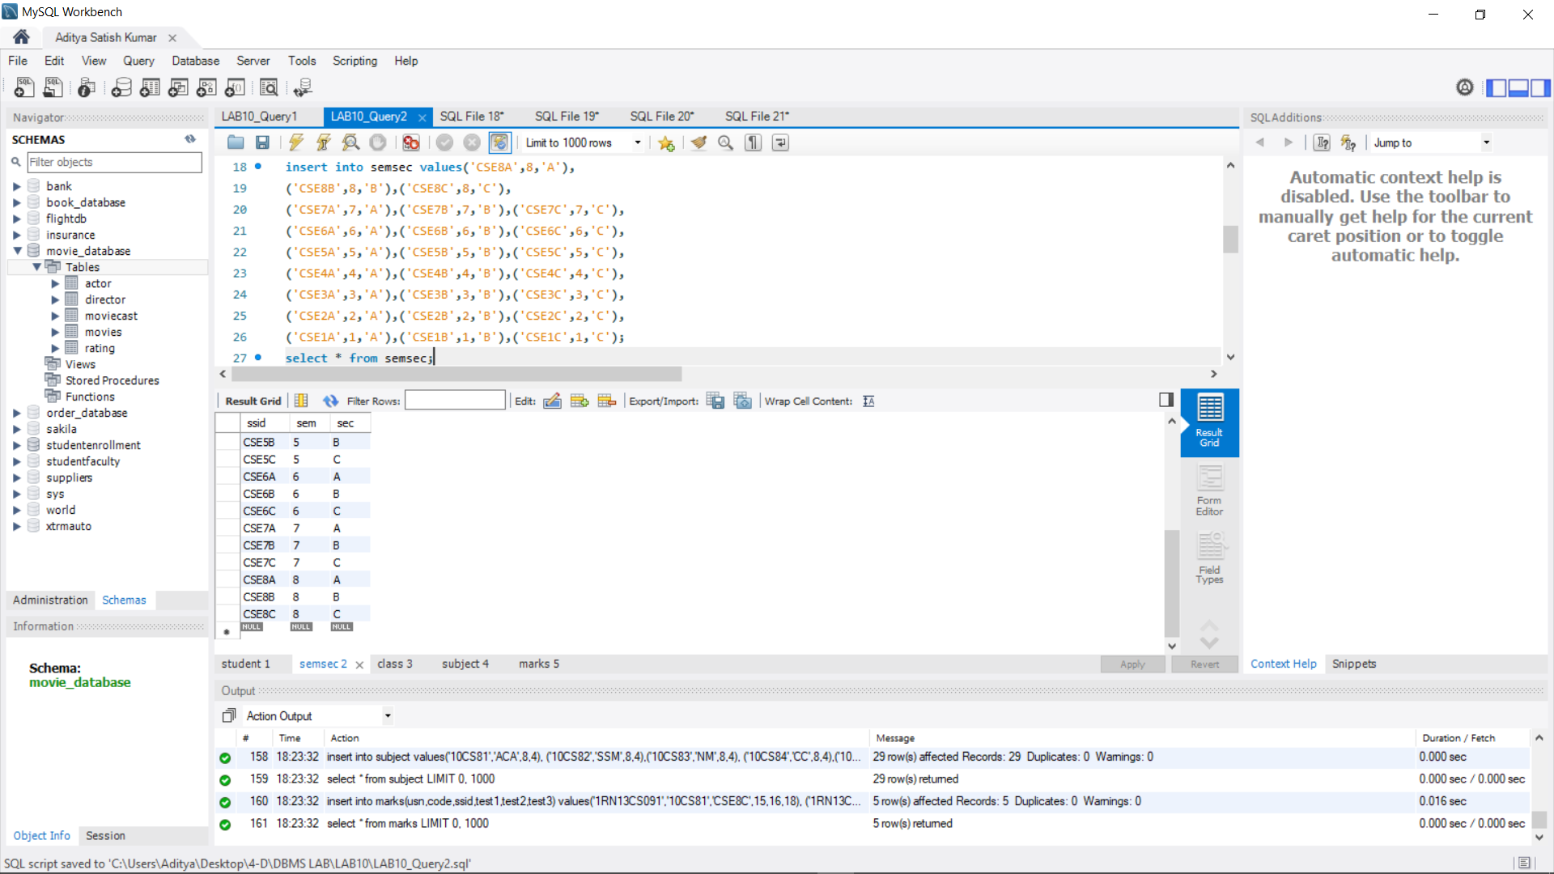

insert into class values('1RN13CS020','CSE8A'),

('1RN13CS062','CSE8A'),('1RN13CS066','CSE8B'),('1RN13CS091','CSE8C'),

('1RN14CS010','CSE7A'),('1RN14CS025','CSE7A'),('1RN14CS032','CSE7A'),

('1RN15CS011','CSE4A'),('1RN15CS029','CSE4A'),('1RN15CS045','CSE4B'),

('1RN15CS091','CSE4C'),('1RN16CS045','CSE3A'),('1RN16CS088','CSE3B'),

('1RN16CS122','CSE3C');

select * from class;

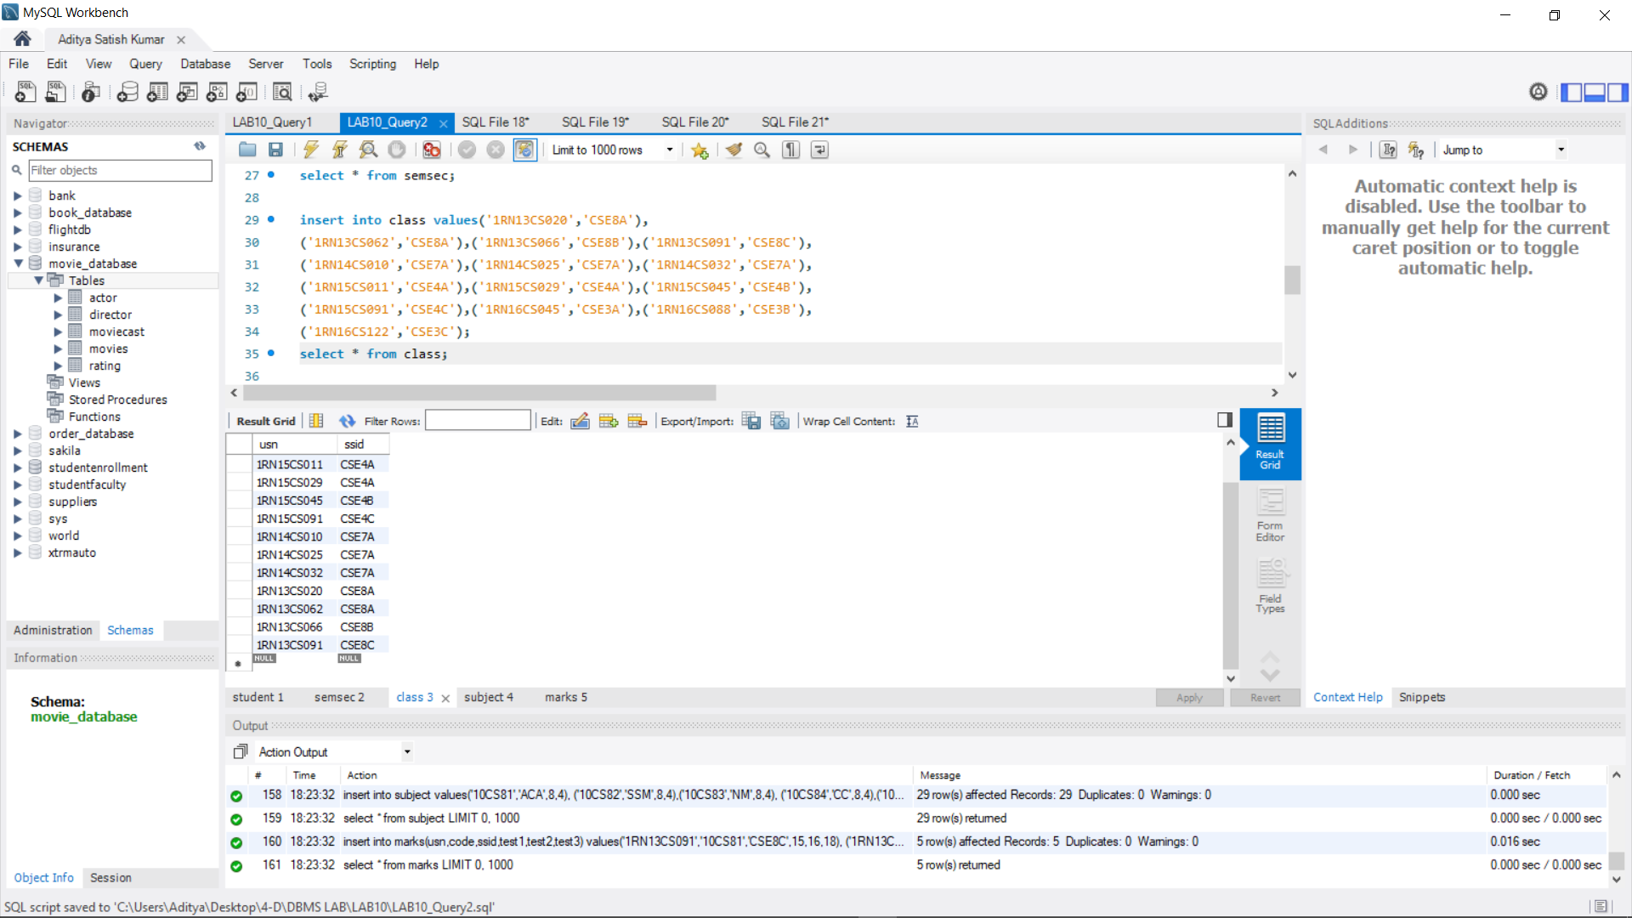

insert into subject values('10CS81','ACA',8,4),

('10CS82','SSM',8,4),('10CS83','NM',8,4),

('10CS84','CC',8,4),('10CS85','PW',8,4),

('10CS71','OOAD',7,4),('10CS72','ECS',7,4),

('10CS73','PTW',7,4),('10CS74','DWDM',7,4),

('10CS75','JAVA',7,4),('10CS76','SAN',7,4),

('10CS51','ME',5,4),('10CS52','CN',5,4),

('10CS53','DBMS',5,4),('10CS54','ATC',5,4),

('10CS55','JAVA',5,3),('10CS56','AI',5,3),

('10CS41','M4',4,4),('10CS42','SE',4,4),

('10CS43','DAA',4,4),('10CS44','MPMC',4,4),

('10CS45','OOC',4,3),('10CS46','DC',4,3),

('10CS31','M3',3,4),('10CS32','ADE',3,4),

('10CS33','DSA',3,4),('10CS34','CO',3,4),

('10CS35','USP',3,3),('10CS36','DMS',3,3);

select * from subject;

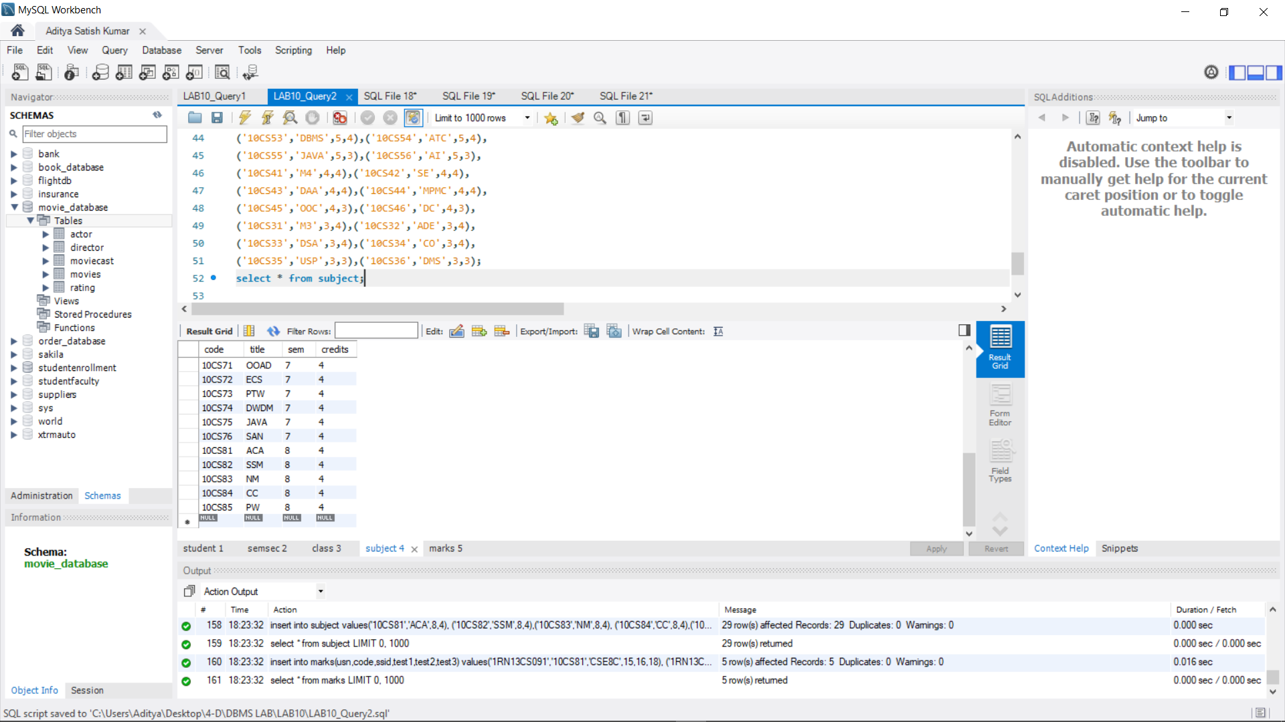

insert into marks(usn,code,ssid,test1,test2,test3) values('1RN13CS091','10CS81','CSE8C',15,16,18),

('1RN13CS091','10CS82','CSE8C',12,19,14),('1RN13CS091','10CS83','CSE8C',19,15,20),

('1RN13CS091','10CS84','CSE8C',20,16,19),('1RN13CS091','10CS85','CSE8C',15,15,12);

select * from marks;

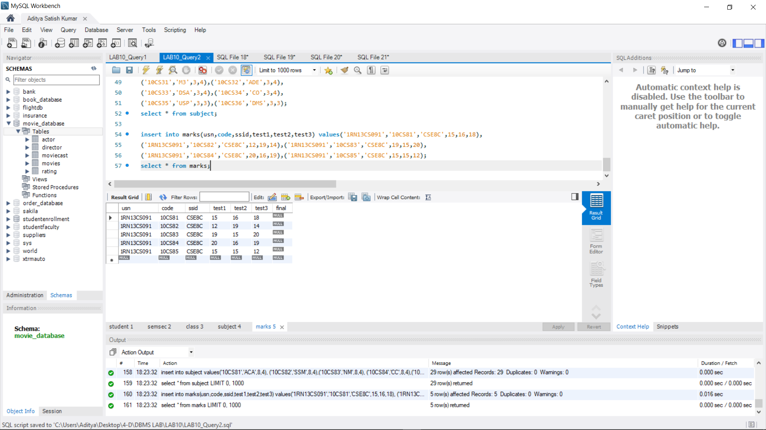

**QUERY 3**

select S.*, SS.sem, SS.sec

from student S, semsec SS, class C

where S.usn = C.usn

AND SS.ssid = C.ssid

AND SS.sem = 4 AND SS.sec = 'C';

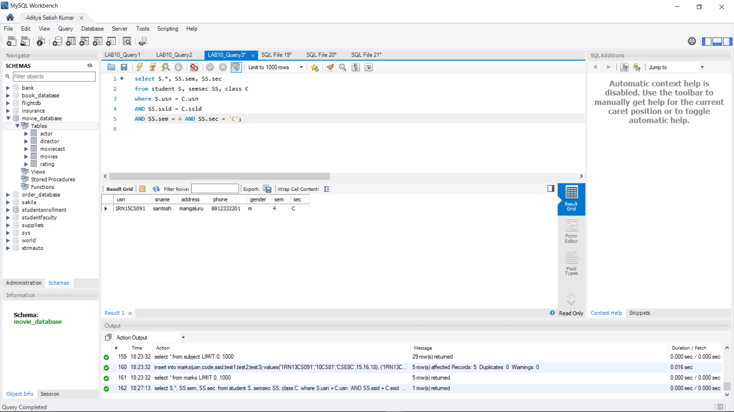

**QUERY 4**

select SS.sem, SS.sec, S.gender, count(S.gender) as COUNT

from student S, semsec SS, class C

where S.usn = C.usn AND SS.ssid = C.ssid

group by SS.sem, SS.sec, S.gender

ORDER by sem;

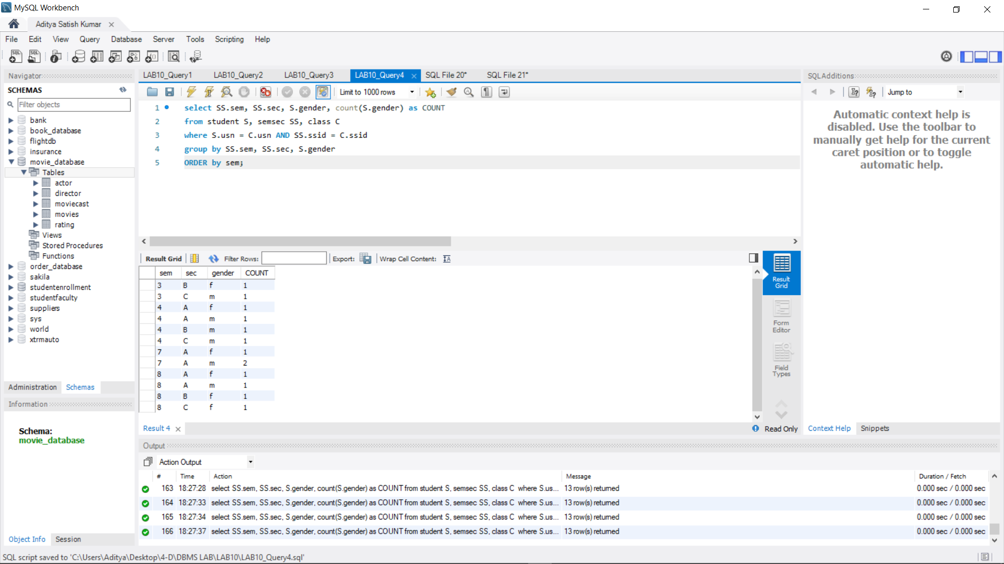

**QUERY 5**

create view STU_test1_marks_view as

select test1, code

from marks

where usn = '1RN13CS091';

select * from STU_test1_marks_view;

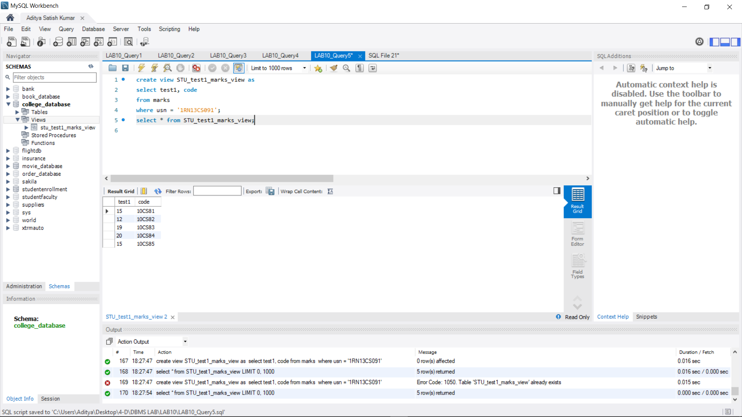

**QUERY 6**

select S.usn, S.sname, S.address, S.phone, S.gender,(CASE

when IA.final between 17 and 20 then 'outstanding'

when IA.final between 12 and 16 then 'average'

else 'weak' end) AS CAT

from student S, semsec SS, marks IA, subject sub

where S.usn = IA.usn

AND SS.ssid = IA.ssid AND sub.code = IA.code AND sub.sem = 8;